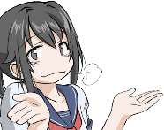Name_______________ Class_______________ Date_______________

Draw a line connecting the character with their 3 hint quiz.

**Who is this**

**James:**

He is very tall.

He is scary.

He is a monster.

**Finn:**

He is a human.

He wears a backpack.

He loves princesses.

**Minnie:**

She is a girl.

She is kind.

She loves Pluto.

**Dora:**

She is a girl.

She wears a backpack.

She speaks Spanish.

**Dipper:**

He is smart.

He wears a cap.

He has a twin sister.

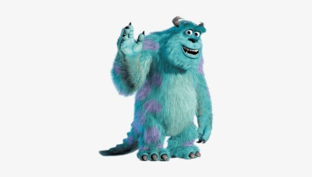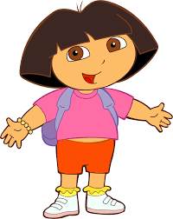

This is Dipper. He is smart and he has a twin sister.

Example:

各数字の横に、このキャラクターが誰であるかを教えてください。

Next to each number please tell me who this character is.

**5. __________________________________________________________________**

**4. __________________________________________________________________**

**3. __________________________________________________________________**

**2. __________________________________________________________________**

**1. __________________________________________________________________**

**1.**

**5.**

**4.**

**3.**

**2.**