Find the student!

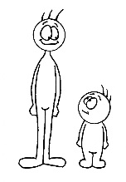  tall/short | I’m taller than __________________________________. | A
 | I’m as tall as ______________________________________. | B
 | I’m shorter than __________________________________. | A

my hair  long/short | My hair is longer than _______________’s hair. | B
 | My hair is as long as ________________________’s hair. | C
 | My hair is shorter than _______________’s hair. | A

my eraser  big/small | ____________________ is bigger than __________________________ | B
 | ____________________ is as big as ______________________________ | D
 | _________________ is smaller than ____________________________ | C

my pencil case  heavy/light | _______________________________________________________________ | D
 | _______________________________________________________________ | C
 | _______________________________________________________________ | B

Points

A: ______ x 1 =
B: ______ x 2 =
C: ______ x 3 =
D: ______ x 5 =
Total:

