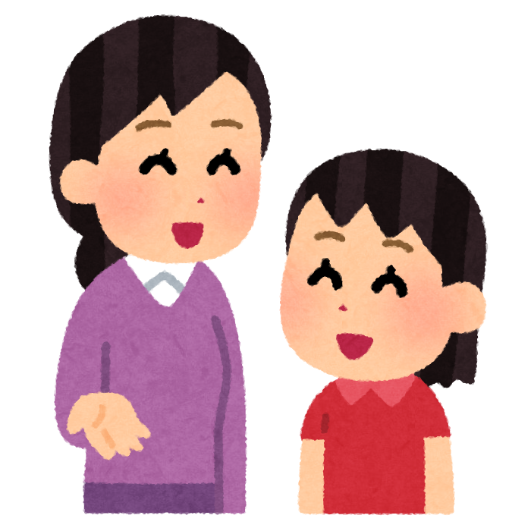

Oh, {繰り返す}

Me too!

OK

Great!

Nice.

Wow!

I see.