Name: _____________
You Must / You Must Not Signs
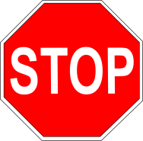

You must ____________.

- _____________________________________________

- ______________________________________________

- ______________________________________________

- _____________________________________________

- _____________________________________________

- _____________________________________________

- _____________________________________________

- ____________________________________________

