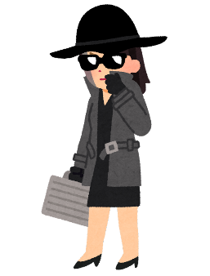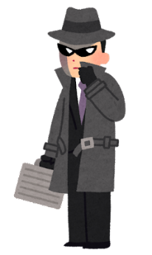

**What will the spy do?**

|  |  |
| --- | --- |
| 1. | 水風船で遊ぶ子供たちのイラスト | かわいいフリー素材集 いらすとやWhat do you do when you are free?  When I am free, I ______________________________. |
| 2. | What do you do when you are at home?  スパイの猫のイラスト食べ物・料理のイラスト | いらすとや  When I am at home, I ______________________________. |