過去分詞 Challenge Time!



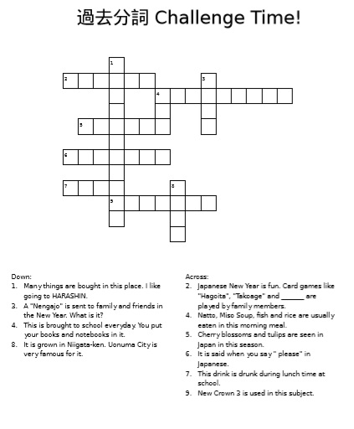

1

3

2

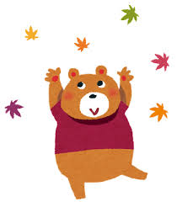

4

5



Down =

Across =

6



8

7

Let’s go!

9

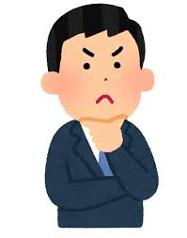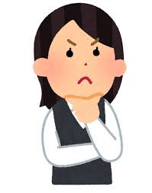

Down:

1. Many things are bought here. I always go to Heiwado for my bento.

3. A “Nengajo” is sent to family and friends in the New Year. What is this?

4. This is brought to school every day. You put your books and notebooks in it.

8. It is grown in Niigata-ken. Uonuma City is famous for it.

Across:

2. Japanese New Year is fun. Card games like “takoage” and “______” are played.

4. Natto, miso soup, fish, and rice are usually eaten in this morning meal.

5. Cherry blossoms are seen in Japan in this season. It’s after winter.

6. When you say “please” in Japanese, this is said. It is written in Romaji.

7. This is drunk during lunch time at school.

9. New Horizon 3 is used to study this subject.

Answer Key

Down:

1. supermarket

3. card

4. bag

8. rice

Across:

2. Karuta

4. breakfast

5. spring

6. kudasai

7. milk

9. English