Name_____________________Class__________

You have 7 submarines.

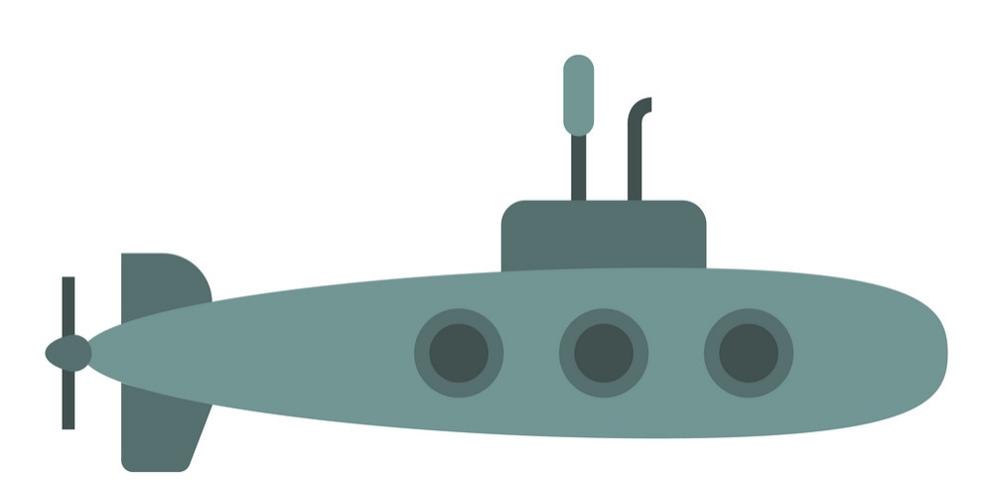

My | happy |  | a baseball fan |  | sad | a doctor | friendly
- Are you…
- Are you…
- Are you…
- Are you…
- Are you…
Yes, I am. |  |  |  | No, I’m not.

-----------------------------------------------------------------------------------------------------------------------------------------------------
My friend’s | happy |  | a baseball fan |  | sad | a doctor | friendly
- Are you…
- Are you…
- Are you…
- Are you…
- Are you…
Yes, I am. |  |  |  | No, I’m not.

