Name _________________________________________ Number ______ Class ______
Who used my toothbrush this morning?
Was it you?

Questions:
1. What is your name?
2. What did you do this morning?
3. Who did you _______________ with?

Name | What did they do? |  | With who?
 |  | with
 |  | with
 |  | with
 |  | with
 |  | with

Ask everyone three questions.

watch TV
Answer from your card. e.g.:

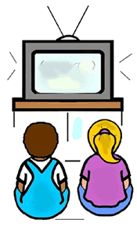
Answers:
1. I’m Sam.
2. I watched TV.
3. I watched TV with Kim.
- You are Sam.
- This morning, you watched TV.
- You watched TV with Kim.

Write what your partner did here. For example: (Sam watched TV with Kim.)

Who used the toothbrush?

What did everyone do? Let’s write! (e.g. Bill played soccer with Tim.)

- ______________________________________________________________________________________.
- ______________________________________________________________________________________.
- ______________________________________________________________________________________.
- ______________________________________________________________________________________.
- ______________________________________________________________________________________.

IDENTITY CARDS

- You are Jill.

- This morning, you talked.

- You talked with Ann.
- You are Ann.  - This morning, you talked.  - You talked with Jill. | - You are Pat.  - This morning you played games.  - You played games with Jack.
- You are Tom.  - This morning, you watched TV.  - You watched TV with Jack. | - You are Jack.  - This morning, you played games  - You played games with Pat.

Tom used the toothbrush.

