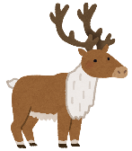  reindeer | 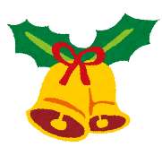  bell | 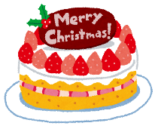  Christmas cake | candle | 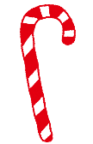  candy cane
Christmas card | 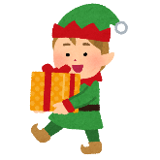  elf | 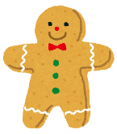  gingerbread man | 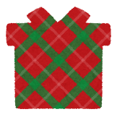  present | ornament
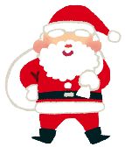  Santa | 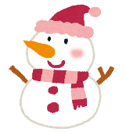  snowman | FREE | 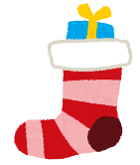  stocking | star
Christmas tree | 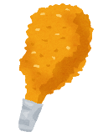  fried chicken | orange | singing | 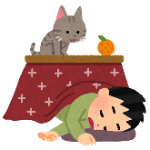  kotatsu
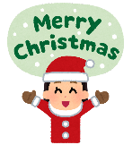  Merry Christmas | 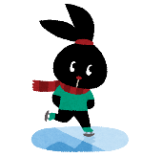  ice skating | shopping | 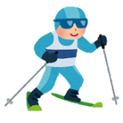  skiing | snowflake

stocking | fried chicken | Santa | candy cane | Christmas card
candle | ornament | shopping | elf | star
Christmas cake | Merry Christmas | FREE | 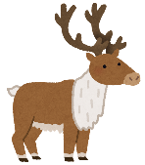  reindeer | present
orange | bell | snowman | Christmas tree | ice skating
singing | snowflake | gingerbread man | kotatsu | skiing

orange | kotatsu | Christmas tree | present | bell
snowman | ice skating | singing | candle | Merry Christmas
skiing | gingerbread man | FREE | snowflake | shopping
Christmas cake | stocking | reindeer | Christmas card | fried chicken
ornament | elf | Santa | star | candy cane

star | ornament | elf | ice skating | stocking
skiing | Christmas cake | orange | Santa | Christmas tree
gingerbread man | fried chicken | FREE | candy cane | reindeer
present | snowflake | bell | snowman | Merry Christmas
shopping | candle | kotatsu | Christmas card | singing

snowflake | ice skating | Merry Christmas | orange | star
singing | shopping | reindeer | skiing | fried chicken
kotatsu | snowman | FREE | elf | Christmas tree
candy cane | ornament | candle | Christmas card | Santa
Christmas cake | bell | present | stocking | gingerbread man

fried chicken | snowman | Santa | Merry Christmas | reindeer
candle | star | ornament | snowflake | bell
candy cane | present | FREE | skiing | stocking
orange | Christmas card | Christmas tree | Christmas cake | shopping
Gingerbread man | kotatsu | ice skating | elf | singing

ornament | present | skiing | fried chicken | snowman
Christmas cake | kotatsu | candy cane | orange | candle
snowflake | star | FREE | ice skating | gingerbread man
Santa | reindeer | singing | Merry Christmas | elf
shopping | Christmas card | bell | stocking | Christmas tree

skiing | Christmas card | gingerbread man | singing | Elf
bell | candy cane | ice skating | shopping | snowflake
stocking | kotatsu | FREE | Santa | snowman
Merry Christmas | Christmas tree | ornament | candle | star
fried chicken | Christmas cake | present | reindeer | orange

