holiday
abroad
aunt
uncle
husband
golden week
far
will
seafood
reservation
Merlion
meter
tall
weigh
ton
gift
cookie
ferris wheel
ride
rode
scary
communicate
culture
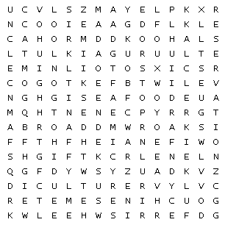
malay
Unit 1 Vocabulary Search
chinese
tamil
guest
clerk
air conditioner
certainly
apologize
trouble
wife

