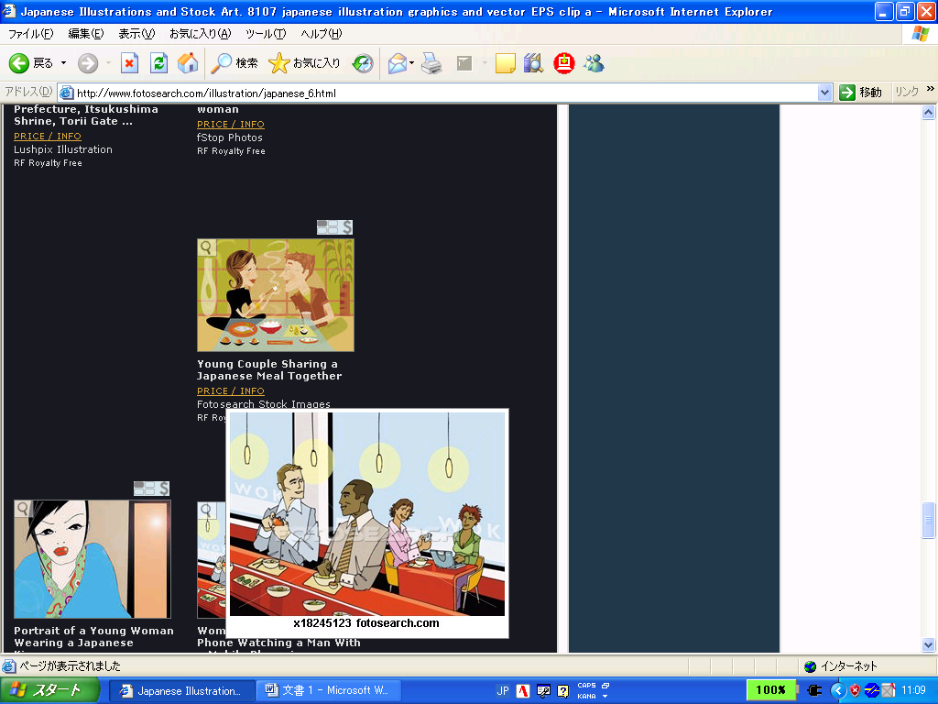

Do you know… Interview game!

Yes, I do. No, I don’t.

Do you know **how to** use chopsticks?

Yes, I do.

|  |  |  |  |
| --- | --- | --- | --- |
| Cooking Curry clipart. Free download transparent .PNG | Creazilla  Do you know **how to** cook curry? | Kanji - Smith's School of English  Do you know **how to** write kanji? | Do you know **where to** eat delicious sushi? | 1,600+ Japan High School Girl Illustrations, Royalty-Free Vector Graphics & Clip  Art - iStock |
|  | Do you know **when to** watch Itte-Q? | Do you know **how to** swim? |  |
| Free clip art "Dancing Penguins" by Moini  Do you know **where to** see penguins? | Eating With Chopsticks Clipart, HD Png Download - kindpng  Do you know **how to** use chopsticks? | 世界の果てまでイッテQ! | テレビ番組制作の株式会社ドックスBoy is Swimming clipart. Free download transparent .PNG | Creazilla |  |
|  | Do you know **how to** speak Sendai-ben? | Do you know **where to** go shopping? |  |
| Free Vectors | studying for a test  Do you know **what to** study for the test**?** | Do you know **when to** go to school? | C:\Users\9712647\AppData\Local\Microsoft\Windows\INetCache\Content.MSO\293BD897.tmp | Go Shopping PNG Images With Transparent Background | Free Download On  Lovepik |
| Do you know **where to** go for the onsen? |  |  |  |
| Do you know **when to** eat school lunch? | Hot Springs Clipart Vector, Winter Japanese Hot Spring Illustration, Enjoy  A Hot Spring, Japan, Family PNG Image For Free Download | Kids Playing Basketball Vector Art, Icons, and Graphics for Free Download  Do you know **how to** play basketball? | Student Using Smartphone During Class Royalty Free SVG, Cliparts, Vectors,  And Stock Illustration. Image 71497911.  Do you know **how to** use a smartphone? |
|  |  |  |  |



Do you know **when to** go to club activities?

**Write four sentences using the information from the table.**

Example: Kaito knows **how to** write kanji.

Kaito doesn’t know **how to** write kanji.

1. ________________________________________________________________________________________________
2. ________________________________________________________________________________________________
3. ________________________________________________________________________________________________
4. ________________________________________________________________________________________________