Hotel Help!
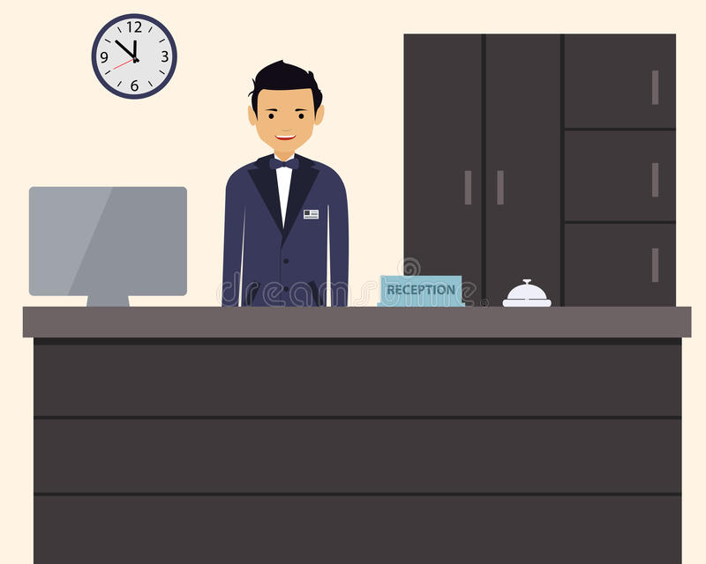

Here are a few of the nicest hotels in the world! They are very famous!
 | 1 | 2 | 3 | 4
 | 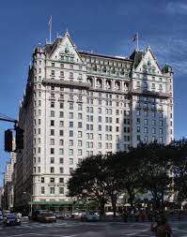 | 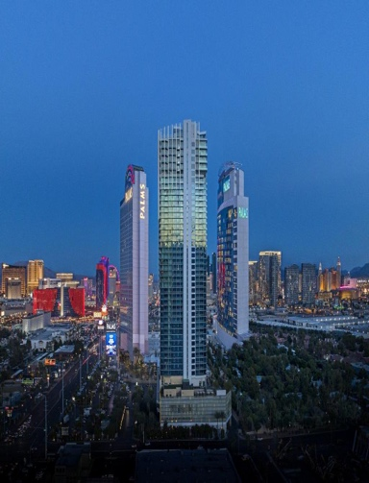 | 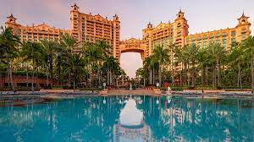 | 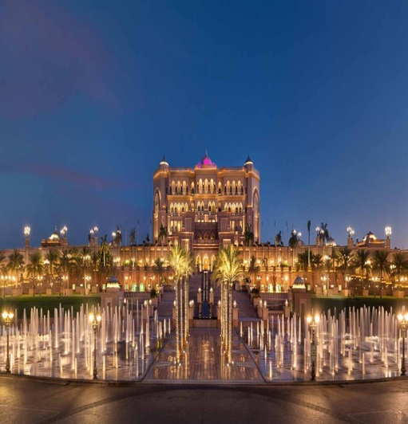
Name of Hotel | The Plaza | The Palms | The Atlantis | The Emirates Palace
Complaint | The room is too small. | The people next door are too loud! | The shower doesn’t work. | There aren’t any towels.
Solution

Step 1: Match the correct solution from the Word Bank below to the complaint and write it in.
I will send you more towels! I will send someone to fix it! I will ask them to quiet down! I will move you to a bigger room!

Step 2: Make a dialogue! Pick your favorite hotel and fill in the dialogue.

- Clerk: Hello, this is _______________________ hotel. How can I help you?
^{name of hotel}
- Guest: Yes, hello. Can you help me? I have a problem with my room!
- Clerk: Oh, I am so sorry! Of course I can help. What is the problem?
- Guest: _____________________________________________________________________________. . ^{write the complaint}
- Clerk: I apologize for the trouble! _______________________________________________________.
^{write the solution}
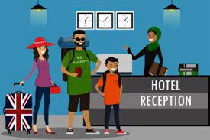
- Guest: Thank you very much. I really appreciate it.
- Clerk: It’s my pleasure. Is there anything else you need help with?
- Guest: No, that is all.
- Clerk: Okay, have a nice day!
Step 3: Find a partner and practice reading your dialogue!

