Name: ________________________ Date:_______________
Do you have to~?
Bingo
- Ask your classmates “Do you have to ~ today?”
- If the answer is yes, draw a ｗrite their name in the ( ).
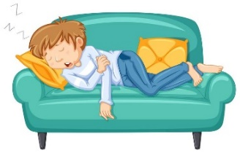  take a nap | 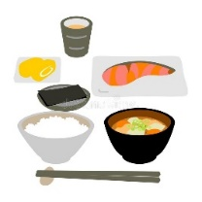  eat breakfast | 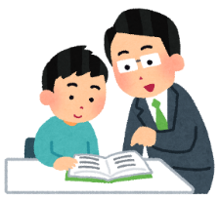  go to Juku | go shopping
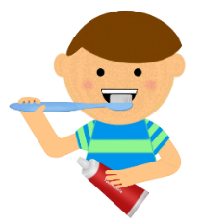  brush your teeth | 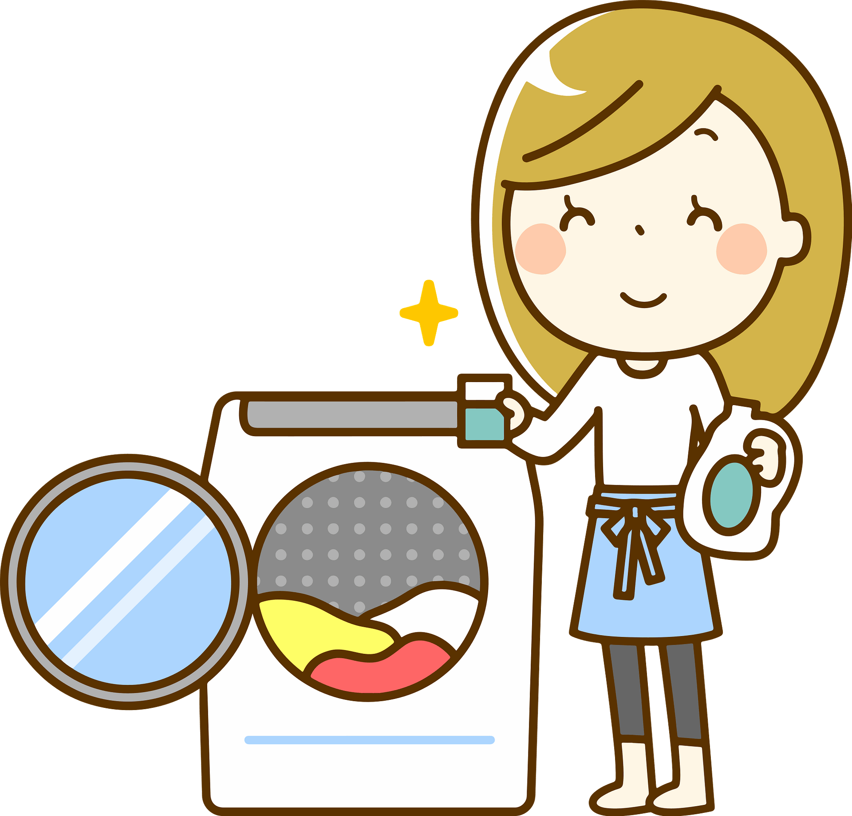  do laundry | 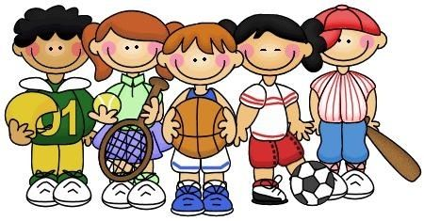  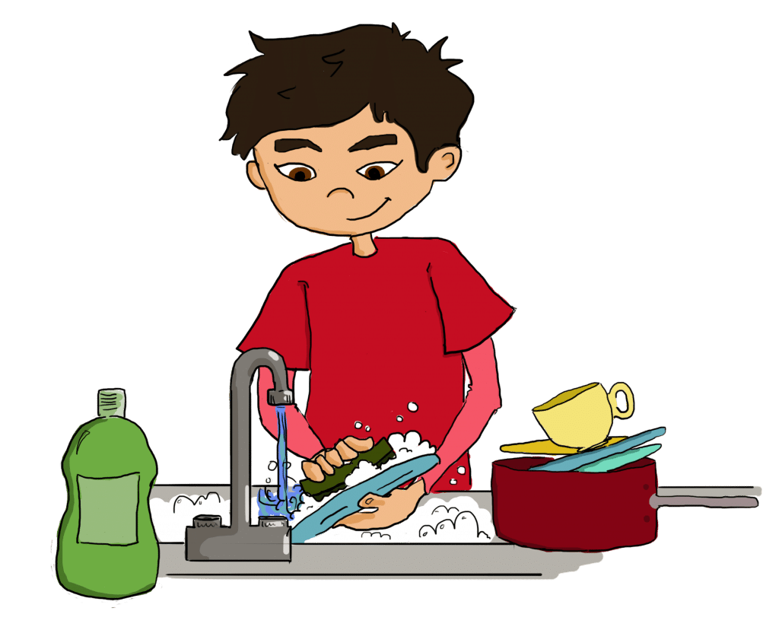  do the dishes | do club activities
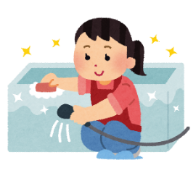  clean the bathroom | do homework | bike home | 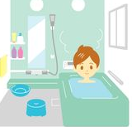  take a bath
study English | 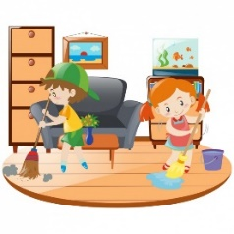  clean your room | 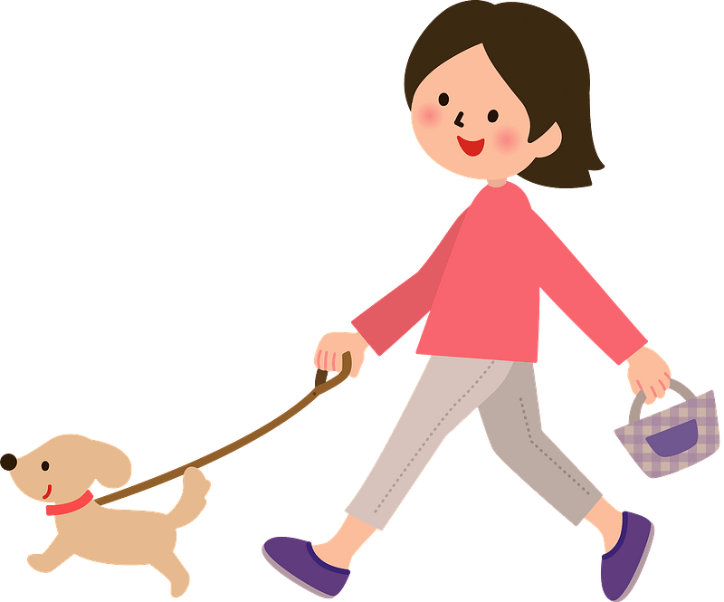  walk the dog | 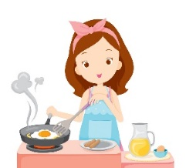  make dinner

２．Writing practice (other side).
Writing Practice:
1. 自分がしなくてはいけないこと

＿＿＿＿＿＿＿＿＿＿＿＿＿＿＿＿＿＿＿＿＿＿＿＿＿＿＿＿＿＿＿＿＿＿
2. 自分がしなくても良いこと

＿＿＿＿＿＿＿＿＿＿＿＿＿＿＿＿＿＿＿＿＿＿＿＿＿＿＿＿＿＿＿＿＿＿
3. 他の人がしなくてはいけないこと

＿＿＿＿＿＿＿＿＿＿＿＿＿＿＿＿＿＿＿＿＿＿＿＿＿＿＿＿＿＿＿＿＿＿
4. 他の人がしなくてはいけないこと

＿＿＿＿＿＿＿＿＿＿＿＿＿＿＿＿＿＿＿＿＿＿＿＿＿＿＿＿＿＿＿＿＿＿
5. 他の人がしなくても良いこと

＿＿＿＿＿＿＿＿＿＿＿＿＿＿＿＿＿＿＿＿＿＿＿＿＿＿＿＿＿＿＿＿＿＿
6. 他の人がしなくても良いこと

＿＿＿＿＿＿＿＿＿＿＿＿＿＿＿＿＿＿＿＿＿＿＿＿＿＿＿＿＿＿＿＿＿＿

