apply
paralympic
somewhere
below
ever
been
match
internet
athlete
championship
amazed
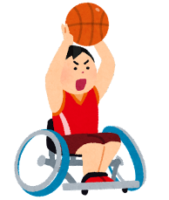
speed
uncomfortable
winner
possible
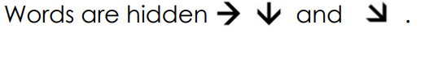established
Unit 1 Vocabulary Search
user
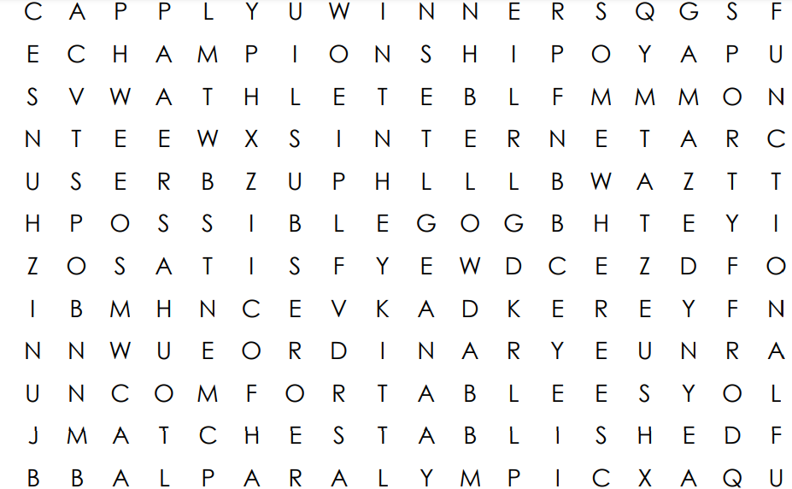satisfy
ordinary
sporty
functional
opinion
awesome
bright
audience
challenge
