Entering the staff room
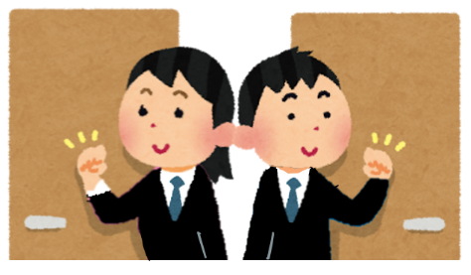
Excuse me.
失礼します。
I’m ( 名前 ) from class ( _ )-( _ ).
year
class
I’m ( 名前 ) from the ( 部活 ) club.

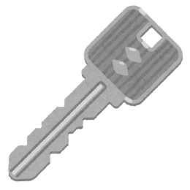
May I borrow the key to class ( _ )-( _ )?
year
class
借りてもよろしいですか
May I borrow the ( 部活 ) club key?
I am returning the key. May I come in?
入ってもよろしいですか。
返しています

Is (Ms. / Mr.) ( 先生の名前 ) here?
○○先生はいらっしゃいますか。

Thank you.

