 Where are these Xmas foods eaten?

Many countries celebrate Christmas, and they have special, yummy foods!

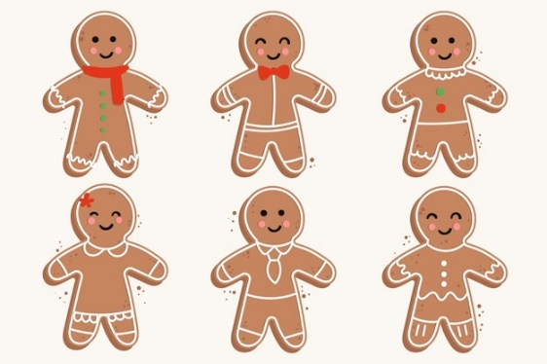🡪 Let’s start!

|  |  |  |
| --- | --- | --- |
| 1. Buche de Noel   Buche de Noel Recipe ( ログ クリスマス ケーキ ) | Japanese Recipes | Uncut Recipes | 1. Roast Ham (with Pineapples)   Recipe Grace Smoked Ham​ | 1. KFC   9月15日(水)発売】ケンタのオールスターが勢ぞろい！おトクに楽しめる「いいトコどりパック」 ～今だけ「発酵バター入りビスケット」も楽しめる～｜日本 KFCホールディングス株式会社 KFC Holdings Japan, Ltd. |
| 4,310 BEST Christmas Greenery Border IMAGES, STOCK PHOTOS &amp; VECTORS | Adobe  Stock_______________ | _______________ | _______________ |



|  |  |  |
| --- | --- | --- |
| 1. Panettone   子供のための特別なパネトーネ-レシピ| レシピ | 1. Mince Pies   Traditional Mince Pies Recipe | Dr. Oetker | 1. Oliebollen   Zelf oliebollen maken - Chickslovefood |
| _______________ | _______________ | _______________ |



|  |  |  |
| --- | --- | --- |
| 1. Lechon   セブ島のNo.1レチョンなら「House of Lechon」 | 留学JP 代表者ブログ | MBA留学後フィリピン、セブ島での企業運営について | 1. 4,310 BEST Christmas Greenery Border IMAGES, STOCK PHOTOS &amp; VECTORS | Adobe  StockSalmon Pie   christmas | 1. Pigs in Blankets   Christmas 2021: Best pigs in blankets to serve at your Christmas dinner |
| _______________ | _______________ | _______________ |

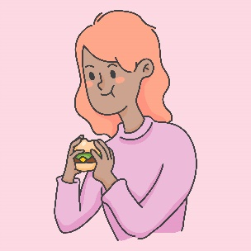Bon Appetit!

I got _______________ out of 9.

Questions

1. What do you want to **try the most**? ______________________________
2. What do you **eat on Christmas day**? ______________________________
3. Can you eat **KFC** **every day**? ______________________________________
4. What is your **perfect** Christmas **dinner**? ______________________________________

Name ( ) Class ( ) No ( )

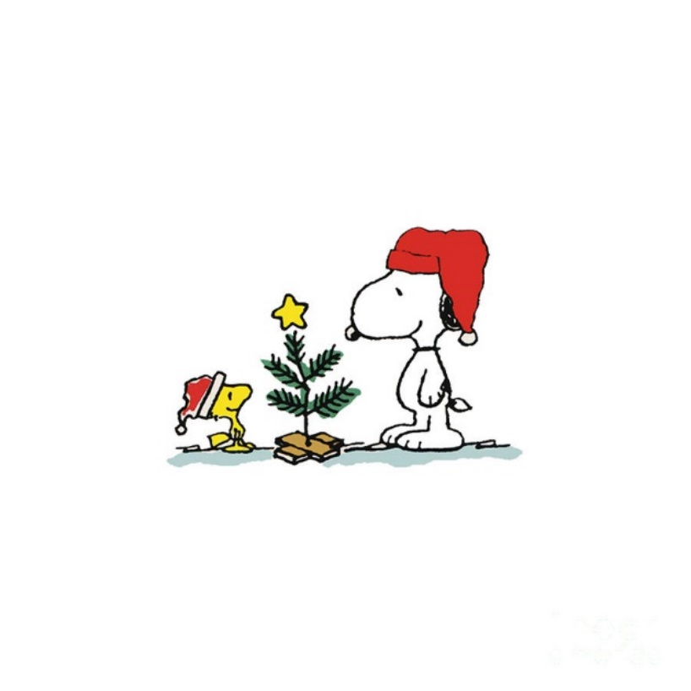Christmas Music!

With just over a week left until Christmas, let’s get into the spirit everyone!

1. Ariana Grande – Santa Tell Me

(1. S ), tell me if you’re really there  
Don't make me fall in love again if he won't be here next (2. y )  
Santa, tell me if he really cares  
'Cause I can't give it all away if he won't be here next (3. y )

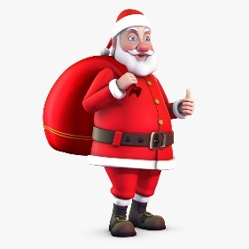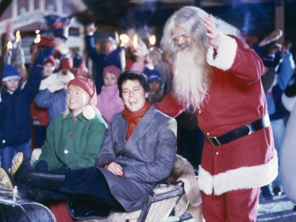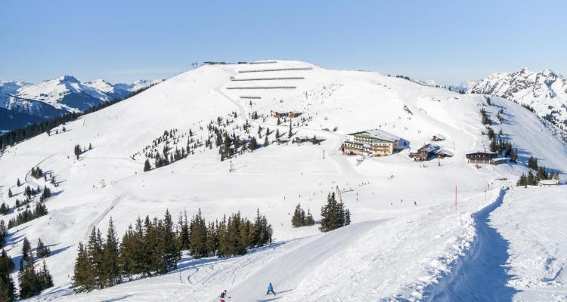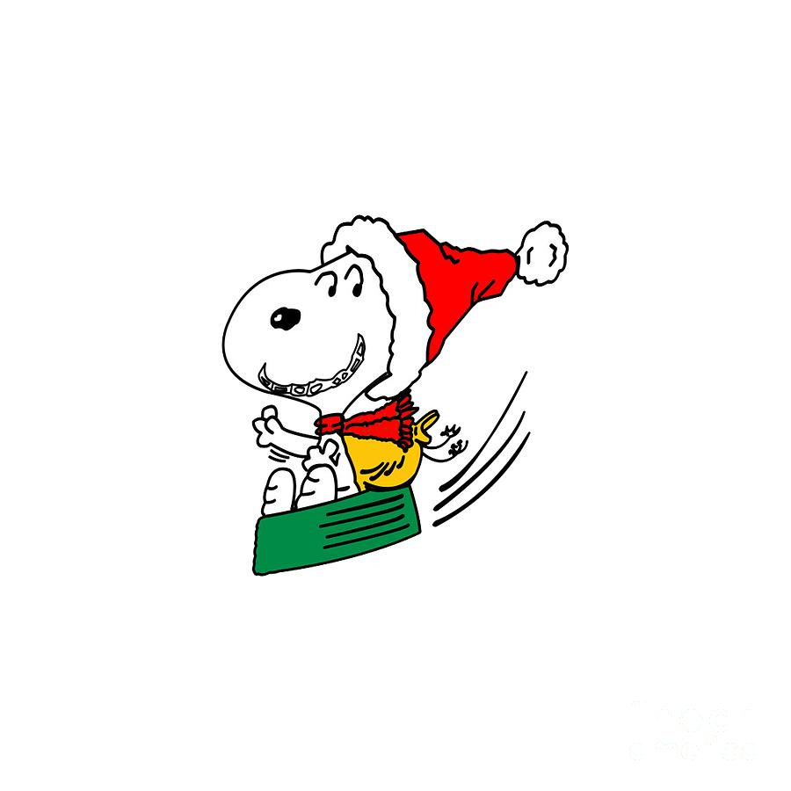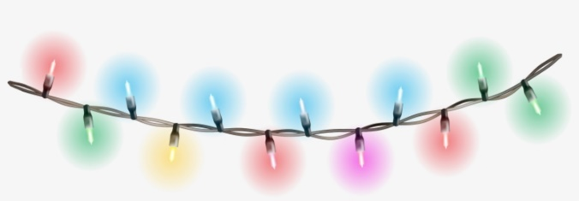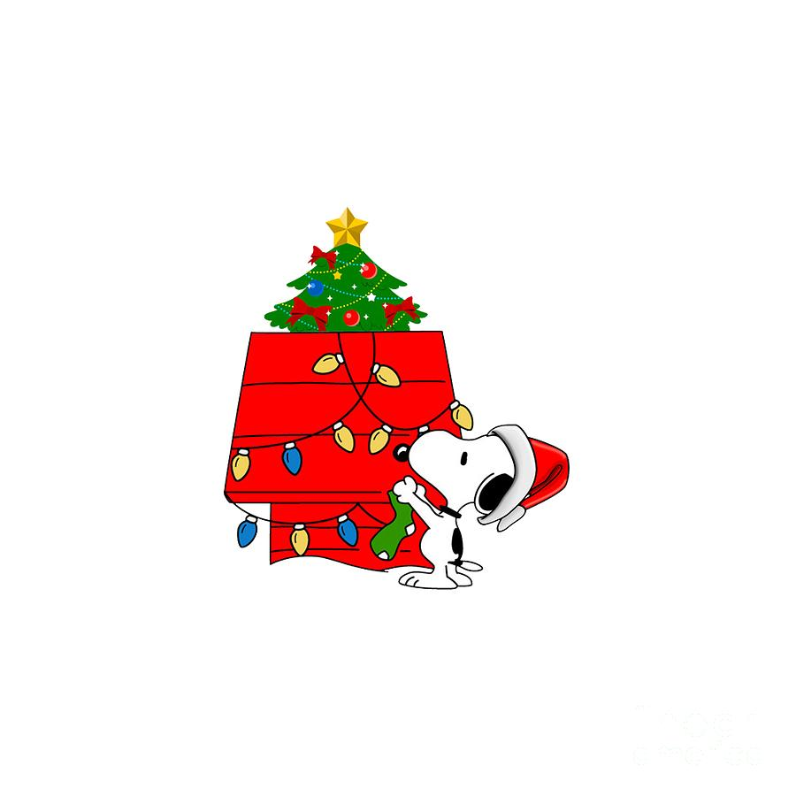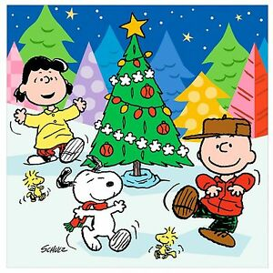

Name ( ) Class ( ) No ( )

4. Shakin’ Stevens – Merry Christmas Everyone

We're gonna have a party tonight  
I'm gonna find that girl  
Underneath the mistletoe  
We'll kiss by candle light  
(1. S ) is fallin'  
All around me  
Children playing  
Having (2. f )  
It's the season  
(3. L ) and understanding  
Merry Christmas everyone  
Merry Christmas (4. e )

**Merry Christmas!**

2. Dean Martin – Let it snow! Let it snow!

Oh, the weather outside is frightful  
But the fire is so delightful  
And since we've no place to (1. g )  
Let it snow, let it snow, let it snow  
Man, it doesn't show signs of (2. s )  
And I've brought me some corn for popping  
The lights are turned way down (3. l )  
Let it snow, let it (4. s )

3. Justin Bieber – Santa Claus is Coming to town

Santa Claus is coming to town

You better watch out  
You better not (1. c )  
You better not pout  
I'm telling you (2. w ),

Santa Claus is coming to town  
He's making a list  
He's checking it (3. t )  
He's going to find out  
Who's naughty and (4. n ),

Santa Claus is coming to town