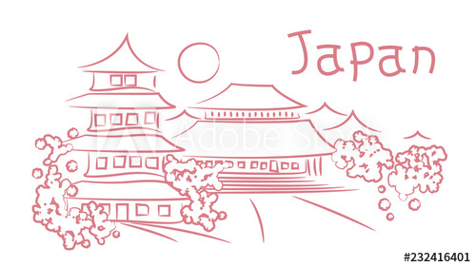
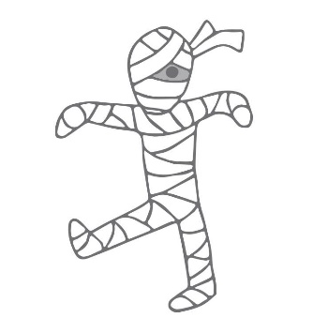
DO YOU KNOW
Name: _____________ Class: ____ Number: _____
JAPAN?
Do you know when the most difficult month in Japan is?
I think it is February. We have many tests.
ONE
_______________________________________________________________
_______________________________________________________________
_______________________________________________________________
TWO
_______________________________________________________________
_______________________________________________________________
_______________________________________________________________
THREE
_______________________________________________________________
_______________________________________________________________
_______________________________________________________________
FOUR
_______________________________________________________________
_______________________________________________________________
_______________________________________________________________
FIVE
_______________________________________________________________
_______________________________________________________________
_______________________________________________________________
SIX
_______________________________________________________________
_______________________________________________________________
_______________________________________________________________

