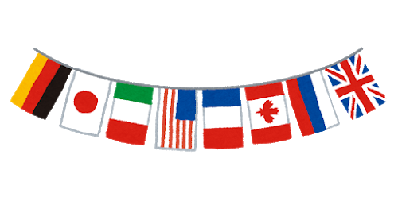
Guess the Country!
My name is______________________________________ Class_____________________ Number____

(言語) is spoken (食べ物) is eaten (生産) is made
(本) was written (飲み物) is drunk (発明) was invented
(スポーツ) is played (作物) is grown (人) was born
(武道や宗教) is practiced

Country 1
1. ________________ is ________ in this country.
2._____________and_______________are __________ in this country.
3._____________ is _________ in this country.
Country 2
1. ________________ was _________ in this country.
2. A lot of _____________ is _________ in this country.
3._____________ was _________ in this country.
Country 3
1. ________________ is _________ in this country.
2._____________ is _________ in this country.
3.___________ are ___________ in this country.

Write passive (受け身)sentence hints about Japan!
- ___________________________________________________________________________
- ___________________________________________________________________________
- ___________________________________________________________________________

Answer Key
Country 1
Canada
1. Maple Syrup is made in this country.
2. English and French are spoken in this country.
3. Hockey is played in this country.
Country 2
China
1. Paper was invented in this country.
2. A lot of tea is drunk in this country.
3. Sangokushi was written in this country.
Country 3
Mexico
1. Spanish is spoken in this country.
2. Soccer is played in this country.
3. Tacos are eaten in this country.

