Name: ______________ Class:_________
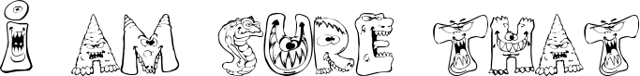

自分：I am sure that a zombie is very scary.
友人:Ken is sure that a zombie is scary.

What are you sure about…? | I am sure that … is …
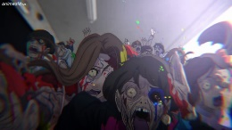  a zombie | I am sure that a zombie is scary.
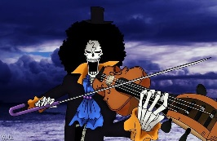
a skeleton

a devil

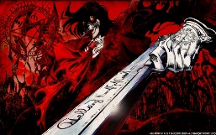
a vampire

a ghoul
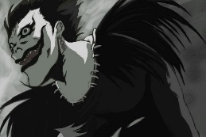
a shinigami
a witch
a wizard
Toolbox (アイデアボックス)
real (本物) scary(怖い) strong (強い) dead(死んだ) ugly(醜い) rotten(腐った) crazy(クレイジー) evil(悪) hungry(お腹がすいた) lovely(素敵な) creepy(気味の悪い) spooky(不気味な)
Step 2: Ask your friend : What are you sure about?

