**What’s your dream job? Janken Game**

Date: .

***JANKEN!***　W-san = 勝者

*L-san:* What do you want to be?

**W-san:** I want to be a ( Job ) !

*L-san:* Cool! / Interesting. / I see.

**W-san:** Goodbye!

**START**

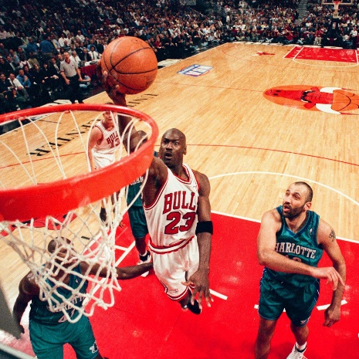

**FINISH**

farmer

basketball player

librarian

hair dresser

fisherman

taxi driver

police officer

baker

voice actor

doctor