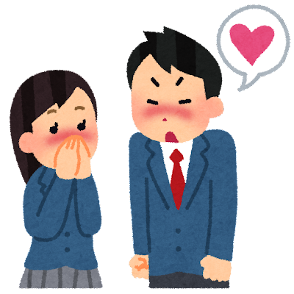
Names: _________________________________
Screenwriters – The Romance Movie

Characters:
-Tomoki (M)
-Sara (F)

Scene: Inside a school hallway. It is lunch.

Tomoki: (Nervous): Excuse me, Sara, can I ___________ to you?

Sara: Yes, what is it Tomoki?

Tomoki: I… I – I’m _________________________________ (that) ____________________
_____________________________________________.

Sara: Wow, Tomoki, I had no idea you felt that way about me… I’m… I’m _________________________ that ________________________________________.

Tomoki: I’m so _______________________.

Sara: Me too. It’s ________________________________________________________.

Tomoki: So how about we meet at _________________________ on ___________________? That could be fun.

Sara: _______________________________! That sounds _______________________. I’m _________________________________ that ________________________________.

[END]

