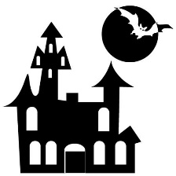
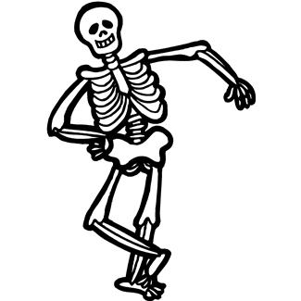
The Halloween Scene!
PART 1
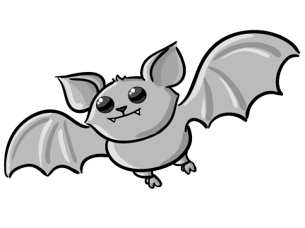
Hints
- Kate is sitting under a tree.  - Ken is wearing a ghost costume.  - Mr. Oda is eating ramen.  - Anna is sitting with Mr. Oda.  - Tom is going Trick or Treating.  - Emi is with Tom. | - Yamato is a vampire!  - Jen has a very long neck.  - Yuki is visiting the Haunted House.  - Harry is with Yuki.  - Shingen is fighting an oni.  - Maru is sleeping on the car.
Kate:____ Ken:____ Mr. Oda:____ Anna:____ Tom:____ Emi:____ Yamato:____ Jen:____ Yuki:____ Harry:____ Shingen:____ Maru:____
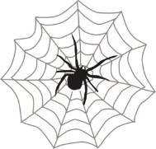
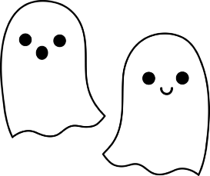
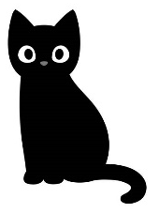

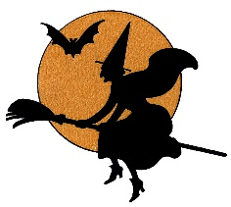
PART 2

Please write the question or the answer. 質問か答えを書いてください。
例 Q1. Who is Kate? 例A1. She is the girl sitting under the tree.
例 Q2. Who is the boy wearing a ghost costume? 例A2. He’s Ken.
Q1. Who is Mr. Oda? A1. He’s the man ___________________________________.
Q2. Who is Anna? A2. She’s ________________________________________.
Q3. Who are ___________ and ___________? A3. They’re the children Trick or Treating.
Q4. Who is the vampire? A4. He’s _______________.
Q5. Who is _______________? A5. She’s the girl with a very long neck.
Q6. Who are the children visiting the haunted house? A6. They’re _______ and _______.
Q7. Who is _________________________________________? A7. He’s Shingen.
Q8. Who is the cat sleeping on the car? A8. She’s _______________.

