Name: ____________ Class: ____ Number: ___ Date: ___/___
ROBOT WRITING
- ~ are fruits we ~ in ~.
_________________________________________________________
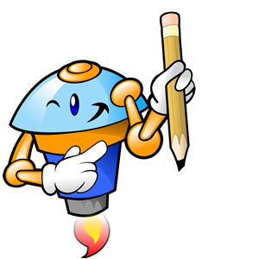
_________________________________________________________
- ~ is a sport ~ ~ well.
_________________________________________________________
_________________________________________________________
- ~ ing ~ is an activity we ~ at home.
_________________________________________________________
_________________________________________________________
- ~ was a book ~ ~ many years ago.
_________________________________________________________
_________________________________________________________
- ~ are items we ~ in class.
_________________________________________________________
_________________________________________________________
- A ~ ~ an animal Kintaro ~ in the mountains.
_________________________________________________________
_________________________________________________________
- ~ is a game we ~ on New Year’s Day.
_________________________________________________________
_________________________________________________________
- My family has a ~ Toyota ~.
_________________________________________________________
_________________________________________________________
- I’m listening to a song ~ ~ well.
_________________________________________________________
_________________________________________________________
- ~ is a ~ we ~ at school.
_________________________________________________________
_________________________________________________________
- ~ are ~ we can ~ in Japan.
_________________________________________________________
_________________________________________________________
- ~ is a character many children ~ on TV.
_________________________________________________________
_________________________________________________________
- ~ were monsters Momotaro ~ on ~.
_________________________________________________________
_________________________________________________________
- I like to use a ~ I got at ~.
_________________________________________________________
_________________________________________________________

