Name: _______________ Class: ______ Number: ___ Date: ___/___
SIGN GAME

- Why do you like this singer?
Because her voice is beautiful.
Because her songs are nice.

- Why do you like this house?
Because it has a nice _________.
Because it has many __________.

- Why is this restaurant good?
Because I like the _________.
Because I like the __________.

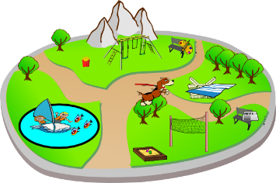
- Why is this park good?
Because it is __________.
Because it is _________.

WHY CHICKS WHY?
- Why do cats like _______?
_________________________________________________
- Why do people like _______?
_________________________________________________
- Why does ______ like ______ _______?
_________________________________________________
- Why does _______ play __________?
_________________________________________________
- Why are the _______ __________?
_________________________________________________
- Why is ____ ______ a good _______ ________?
_________________________________________________
- Why does ________ like ___________?
_________________________________________________
- Why does ____________ love _____________?
_________________________________________________
- ____ is your favorite ________________? Why?
________________________________________________________
________________________________________________________
- ____ is your favorite ________________? Why?
________________________________________________________
________________________________________________________
- ____ is your favorite ________________? Why?
________________________________________________________
________________________________________________________
- ____ is your favorite ________________? Why?
________________________________________________________
________________________________________________________
- ____ is your favorite ________________? Why?
________________________________________________________
________________________________________________________

Because she always helps him.
Because it is delicious.
Because they are great dancers.
Because nature is beautiful.
Because she practices every day.
Because she likes sandwiches.
Because he is a nice boy.
Because her voice is beautiful.
Because she likes chocolate.
Because they have many great players.
Because it is an exciting sport.

BONUS
- Q: ____________________________________________________
A: ____________________________________________________
- Q: ____________________________________________________
A: ____________________________________________________
- Q: ____________________________________________________
A: ____________________________________________________
- Q: ____________________________________________________
A: ____________________________________________________
- Q: ____________________________________________________
A: ____________________________________________________
THE QUESTIONS
- Why do cats like sushi?
- Why do people like green?
- Why does Imoto like Namie Amuro?
- Why does Conan play soccer?
- Why are the Giants strong?
- Why is Naomi Osaka a good tennis player?
- Why does Nobita like Shizuka?
- Why does Dokinchan like Shokupanman?
- What is your favorite subject?
- Who is your favorite singer?
- What is your favorite season?
- Who is your favorite teacher?
- What is your favorite place?

