Name: ________________ Class: _____ Number: _____ Date: ___/___
ROBOT RACE ONE

Do you often climb a tree? Yes, I do. / No, I don’t.
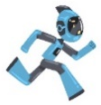  START | 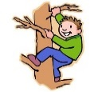  climb a tree | clean your room | study hard | draw a picture | 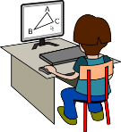  use a computer | listen to music
 | WRITING PRACTICE  Q: ________________________________________  A: ________________________________________  Q: ________________________________________  A: ________________________________________ |  |  |  |  | eat hamburgers
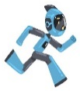  GOAL |  |  |  |  |  | run fast
read a book | play games | sing a song | swim | cook dinner | speak English | watch TV
ROBOT RACE TWO
What sport do you like? I like tennis.
START | 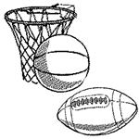  sport | 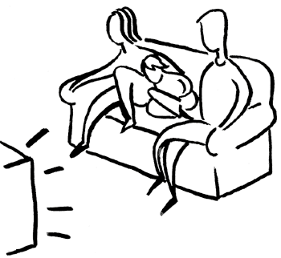  TV show | snack | 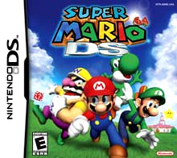  game | music | movie
 | WRITING PRACTICE  Q: ________________________________________  A: ________________________________________  Q: ________________________________________  A: ________________________________________ |  |  |  |  | character
GOAL |  |  |  |  |  | book
ice cream | drink | animal | color | subject | fruit | food

Name: ________________ Class: ______ Number: ____ Date: ___/____
GUESS THE QUESTION ‘WHERE or WHEN’
例: _________ do you _____ tennis? On ___________.
- ___________ do you ___________? At the __________.
- __________ do you __________ a _______? Before __________.
- __________ do you ________ _________? On ___________.
- __________ do you ________ __________? At ___________.
- __________ do you _______ ____ _______? In the __________.
- _________ do you _________? In the _____________.
- ________ do you ________ _________? During ________ ________.
- __________ do you _______ a ____________? In my _______________.
THINK ABOUT QUESTIONS FOR THESE ANSWERS!
1. | Yes, I do.
2. | I like RPG games.
3. | At home.
4. | No, I don’t.
5. | Yes, I do.
6. | I like tennis.
7. | In the summer.
8. | Yes, I do.
9. | I like action movies.
10. | In Nagaoka.

