Name: ___________________
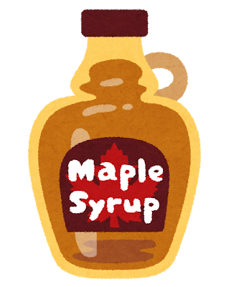

- Where did you go?
I went to カナダ.

It was great / good / okay.

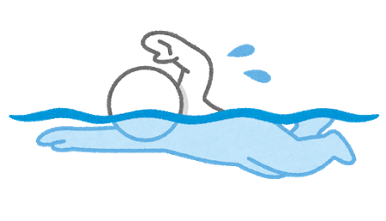

- What did you do?
I enjoyed swimming.

It was fun / hard / good.

- What did you eat?
I ate to pizza

It was delicious / okay.

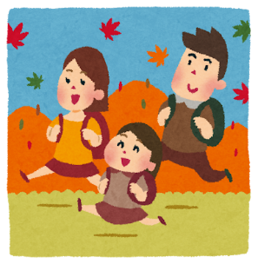

- What did you see?
I saw 家族.

It was nice / beautiful / hard.

