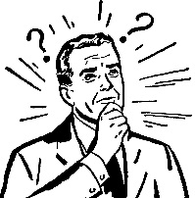
What are they doing?

- They are _________________________________________
- _________________________________________________
- _________________________________________________
- _________________________________________________
- _________________________________________________
- _________________________________________________
- _________________________________________________
- _________________________________________________

