What Started Pride Month?

Pride month started on June 28th, 1969. This is because of the riots that happened in New York City. At that time, LGBT people were not liked in many places. LGBT people lost their jobs, became homeless, or were arrested because they were gay or transgender. Police harassment was a big problem, too. LGBT people fought for gay rights every day but the most famous fight was the Stonewall Riots.

In the early morning of June 28th, police went to the Stonewall Inn, a bar for LGBT people. They wanted to arrest the people inside. New York City's LGBT community was angry because of years of police harassment and discrimination. They started riots that continued for three days. They fought the police and said they want to be seen as normal people. We call this the Stonewall Riots. Transgender women like Marsha P. Johnson and Sylvia Rivera helped to start these riots and begin the international Gay Liberation Movement.

A year after the Stonewall riots, the first Gay Pride march was held. So in America, we remember the Stonewall Riots and continue to fight for rights for LGBT people in June. Other countries have Pride marches to celebrate their own LGBT heroes, too. In Japan, Pride marches are very popular. We can celebrate Nobuko Yoshiya, Matsuko Deluxe, Kazlazer, and more. But, there is more work to do. We need same sex marriage and better family rights in all of Japan. Transgender people need to live the way they want. We need safe places for LGBT people, too. Let’s make them together.

*riot(s):暴動 *arrest(ed): 捕まえる *police harassment: 警察より暴力行為 *rights: 権利 *discrimination: 差別 *Gay Liberation Movement: ゲイ解放運動 *same-sex: 同性愛
もっと知りたい時：https://www.gqjapan.jp/culture/article/20200609-pride-month-2020-1

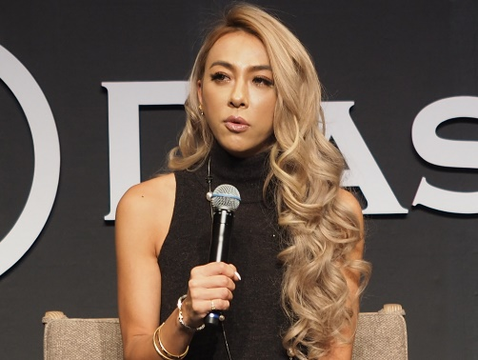
Genking
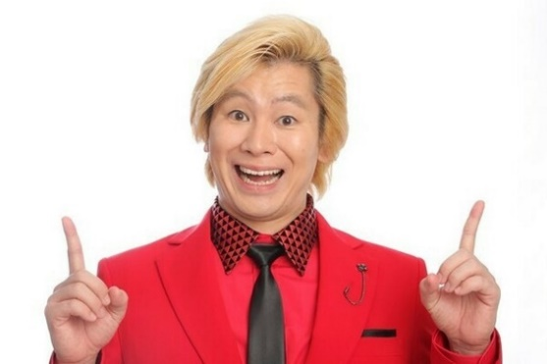
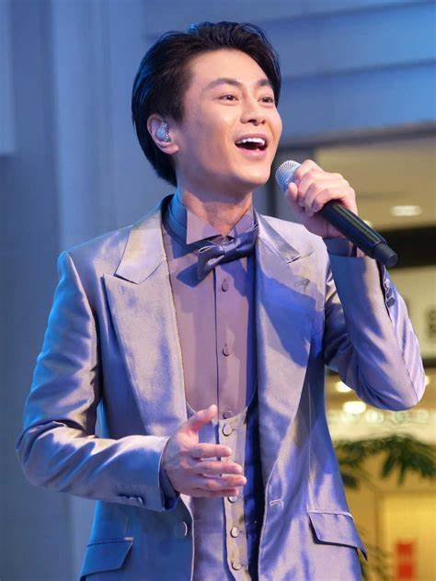
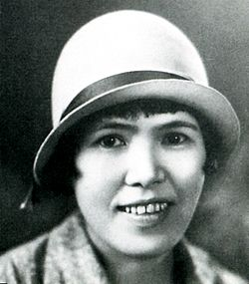
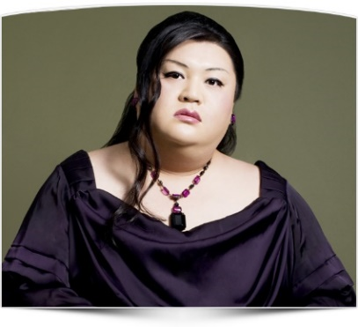
Kazlazer
Koyuki Higashi
Kiyoshi Hikawa
Nobuko Yoshiya
Matsuko Deluxe

