Name : ____________________ Class : ___ Date : _____ How do you . . ?
How do you ride a  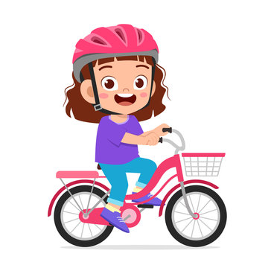  bike? | 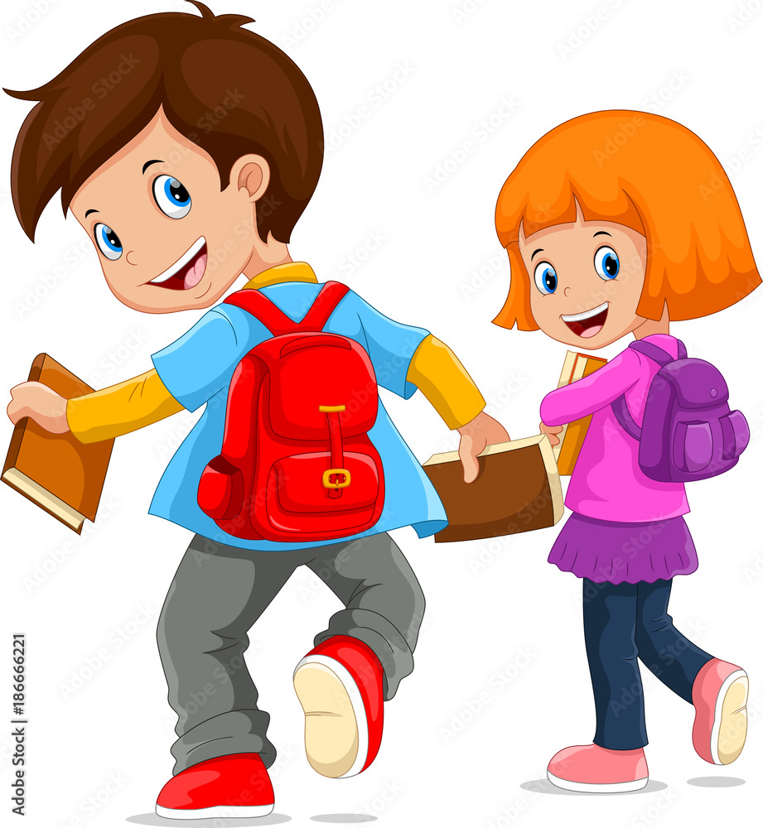  How do you come to school? | 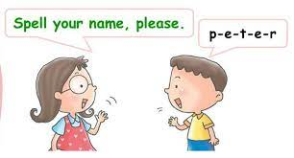  How do you spell your name?
How do you sleep?  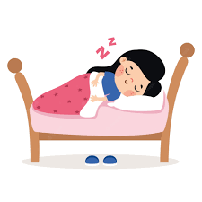 | How do you eat a hamburger? | How do you swim?  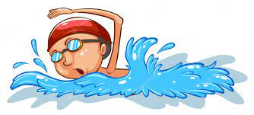
How do you dance?  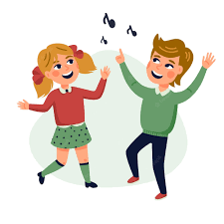 | How do you say konnichiwa in English?  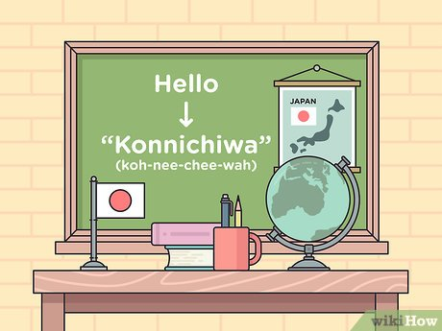 | How do you play basketball?  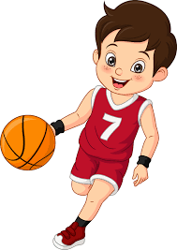

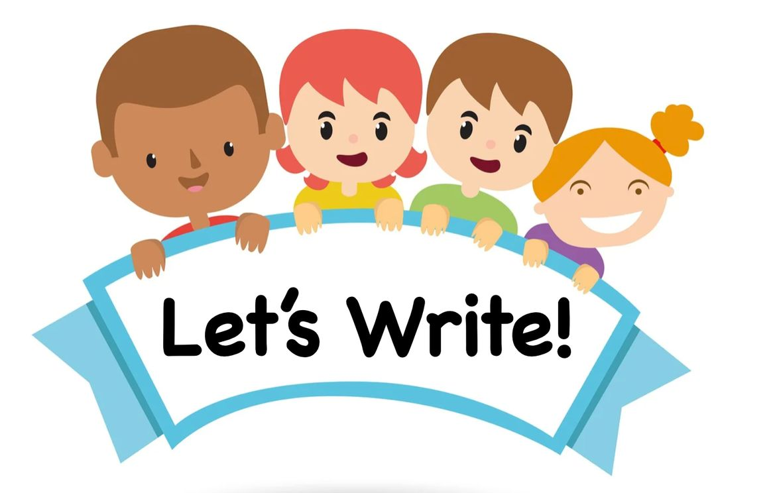

I have (bread/ rice/ soup / cereal /milk / tea/ fish).
I (walk / go by car).
1. What do you have for breakfast?
_________________________________________________________________________________________________________________________________________________________________________________________________________________________________________________________
2.How do you come to school?
_________________________________________________________________________________________________________________________________________________________________________________________________________________________________________________________

