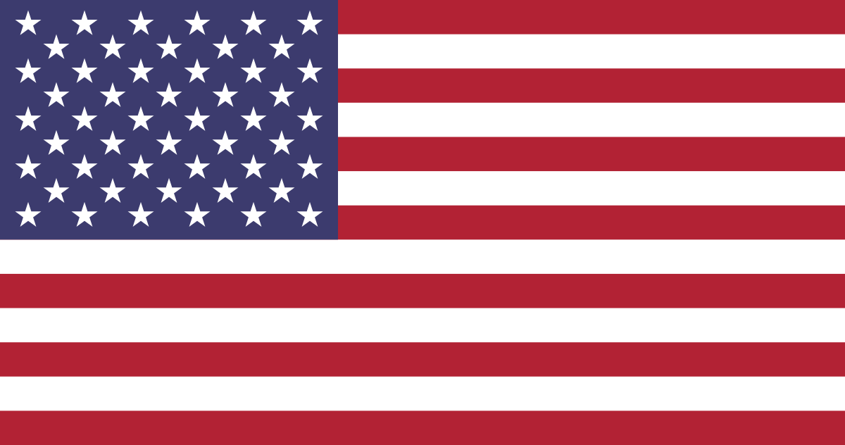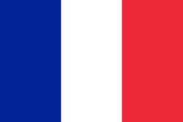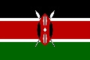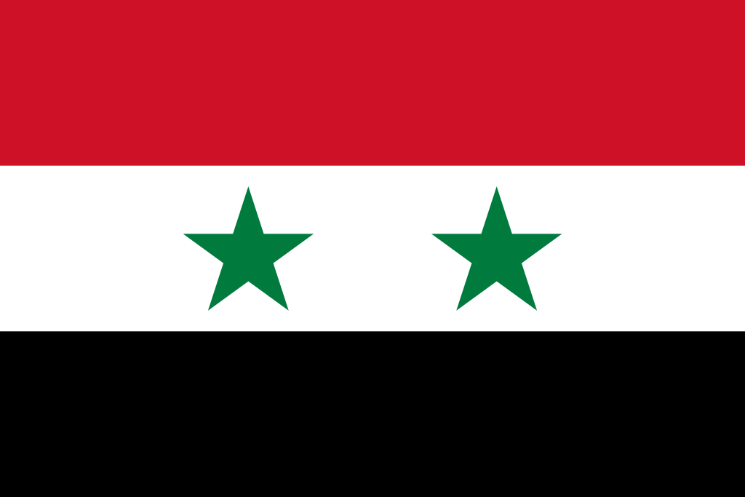Flag of Oman | Britannica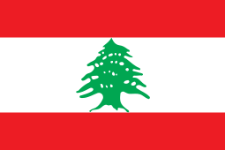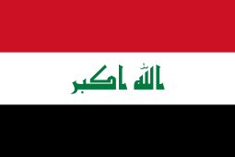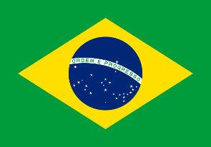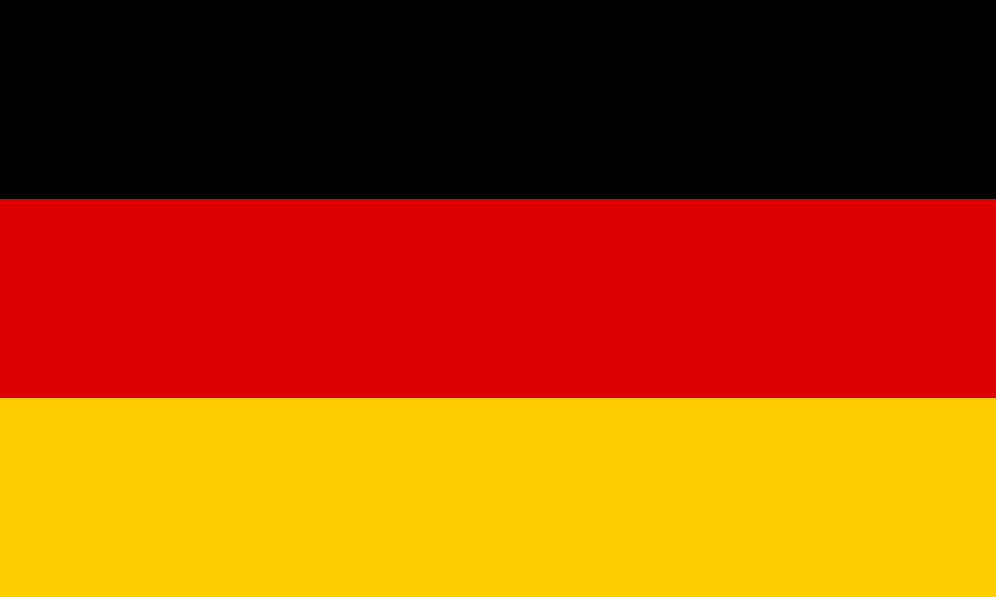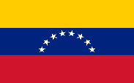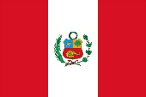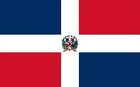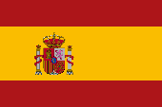

“I love you” around the world!

How other countries say, “I love you!”

\*\*This is a paper craft; the different languages are handwritten inside of paper hearts!!

Languages:

Spain, Dominican Republic, etc. (Spanish): Te amo

Iraq, Lebanon, etc. (Arabic): أحبك / ‘uhibuk

Italy (Italian): Ti amo

France (French): Je t’aime

Germany (German): Ich liebe dich

Brazil (Portuguese): Eu te amo

Canada (English, French): I love you + Je t’aime

United States (English): I love you

Kenya, Burundi, etc. (Swahili): Nakupenda

Poland (Polish): Kocham cię

China (Chinese): 我爱你 / wǒ ài nǐ

Japan (Japanese): 大好きです / daisukidesu

South Korea (Korean): 사랑해 / salanghae

Italy

United States

France

Poland

Japan

South Korea

Kenya, Burundi, and 12 others!

Iraq, Lebanon, Oman, Syria, and 21 others!

Canada

Brazil

China

Germany

Spain, Dominican Republic, Peru, Venezuela, and 16 others!