Name: __________________________________

Places in the city

Write the names of the places.

|  |  |  |  |  |  |  |  |  |
| --- | --- | --- | --- | --- | --- | --- | --- | --- |
|  |  |  |  |  |  |  |  |  |
|  |  |  |  |  |  |  |  |

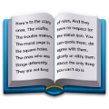1. 本屋

|  |  |  |  |  |  |  |
| --- | --- | --- | --- | --- | --- | --- |
|  |  |  |  |  |  |  |
|  |  |  |  |  |  |
|  |  |  |  |

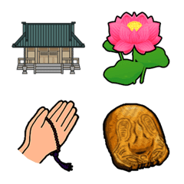

2. 寺

laundromat

temple

cinema

bookstore

bakery

airport

zoo

shrine

pharmacy

hospital

|  |  |  |  |  |  |  |  |
| --- | --- | --- | --- | --- | --- | --- | --- |
|  |  |  |  |  |  |  |  |
|  |  |  |  |  |  |  |  |
|  |  |  |  |  |  |

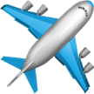

3. くうこう

|  |  |  |  |  |  |
| --- | --- | --- | --- | --- | --- |
|  |  |  |  |  |  |
|  |  |  |  |  |
|  |  |  |  |  |  |

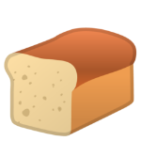

4. パンや

|  |
| --- |
|  |
|  |  |  |

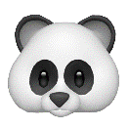

5. どうぶつえん

|  |  |  |  |  |  |
| --- | --- | --- | --- | --- | --- |
|  |  |  |  |  |  |



6. えいがかん

|  |  |  |  |  |  |
| --- | --- | --- | --- | --- | --- |
|  |  |  |  |  |  |
|  |  |  |  |  |  |

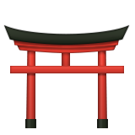

7. 神社

|  |  |  |  |  |  |  |  |
| --- | --- | --- | --- | --- | --- | --- | --- |
|  |  |  |  |  |  |  |  |
|  |  |  |  |  |  |  |  |
|  |  |  |  |  |  |  |  |

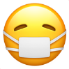

8. 薬屋

|  |  |  |  |  |  |  |  |  |  |
| --- | --- | --- | --- | --- | --- | --- | --- | --- | --- |
|  |  |  |  |  |  |  |  |  |  |
|  |  |  |  |  |  |  |  |  |

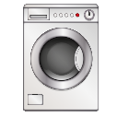

9. せんたくや