NAME ____________________________________ CLASS ____________

Description: C:\Documents and Settings\t27\Local Settings\Temporary Internet Files\Content.IE5\69AN8HUT\MC900241151[1].wmf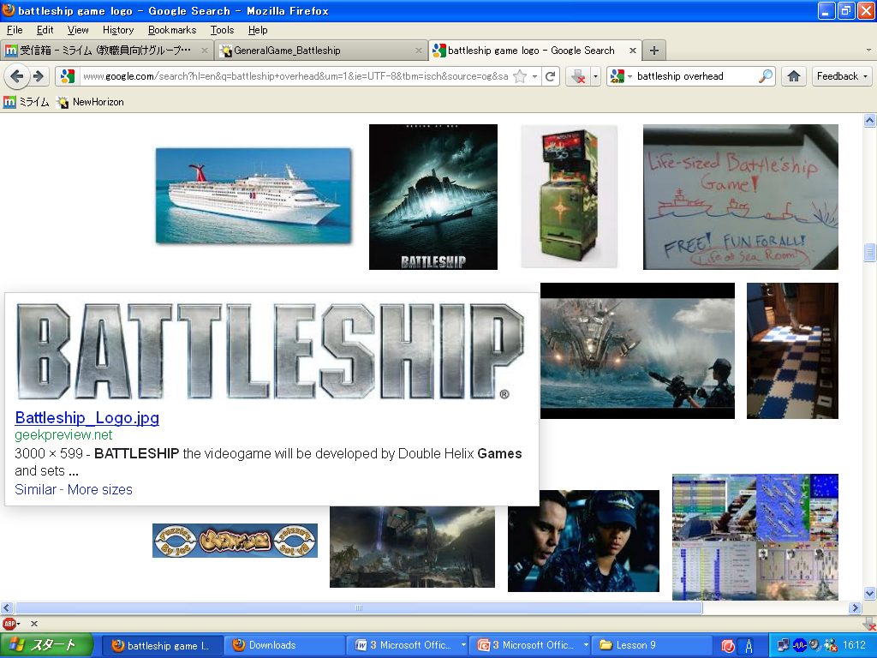Description: C:\Documents and Settings\t27\Local Settings\Temporary Internet Files\Content.IE5\69AN8HUT\MC900241151[1].wmf

**Q:** Is it (in/on/under/by/behind) the ___?

**A: Yes, it is.**  Hit / **No, it isn’t.**  Miss

|  |  |  |
| --- | --- | --- |
| HOME |  | TARGET |
| Place 3 ships unnamed (1).png unnamed (1).png unnamed (1).png |  | Hit = **O** Miss = **X** |

- - - - - - - - - - - - - - - - - - - - - - - - - - - - - - - - - - - - - - - - - - - - - - - - - - - - - - - - - - - - - - - - - - - - - - - - - - - - - - - - - - - - - - - - - - - - - - - - - - - - - - - - - - - - - - - - - - - - - - - - - - - - - - - - - - - - - - - - - - - - - -

|  |  |  |  |  |  |  |  |  |  |  |  |  |  |
| --- | --- | --- | --- | --- | --- | --- | --- | --- | --- | --- | --- | --- | --- |
|  | sofa  C:\Users\10253416\AppData\Local\Microsoft\Windows\INetCache\Content.MSO\83D99AE3.tmp | piano  Image result for piano drawing | table  Image result for table drawing | box  Image result for box drawing | bed  unnamed (2).png |  |  |  | sofa  C:\Users\10253416\AppData\Local\Microsoft\Windows\INetCache\Content.MSO\83D99AE3.tmp | piano  Image result for piano drawing | table  Image result for table drawing | box  Image result for box drawing | bed  unnamed (2).png |
| Image result for on in under by flashcard |  |  |  |  |  |  |  | Image result for on in under by flashcard |  |  |  |  |  |
| Image result for on in under by flashcard |  |  |  |  |  |  |  | Image result for on in under by flashcard |  |  |  |  |  |
| Image result for on in under by flashcard |  |  |  |  |  |  |  | Image result for on in under by flashcard |  |  |  |  |  |
| Image result for on in under by flashcard  by |  |  |  |  |  |  |  | Image result for on in under by flashcard  by |  |  |  |  |  |
| behind.jpg |  |  |  |  |  |  |  | behind.jpg |  |  |  |  |  |