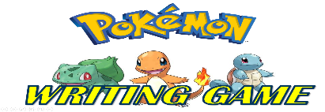
Name: _____________ Class: ____ Number: ___ Date: __/__
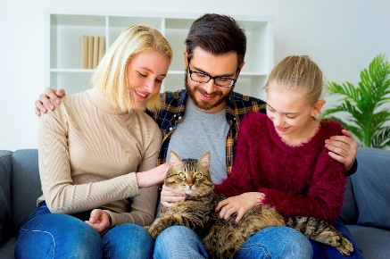
Whose cat is this?
_______________________________________
______________________________________
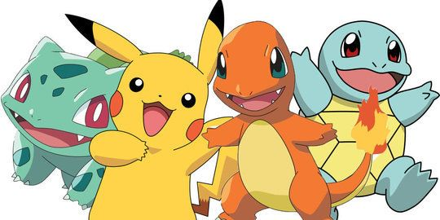
Do you know ______?
_________________________________________
_________________________________________
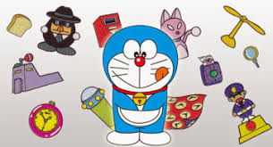
Whose items are these?
_______________________________________
_______________________________________
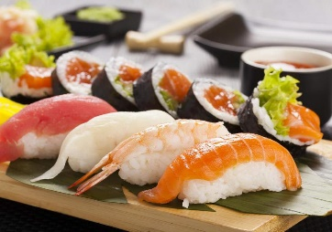
Do you know ______?
________________________________________
________________________________________
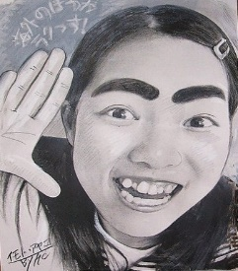
Do you know _____?
___________________________________________
___________________________________________
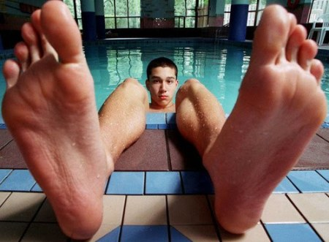
Whose feet are these?
__________________________________________
___________________________________________
Whose country is this?
_________________________________________
_________________________________________
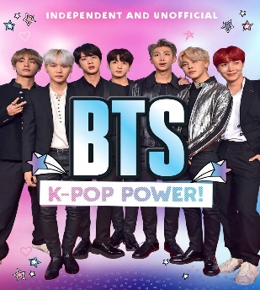
Do you know _____?
_________________________________________
_________________________________________
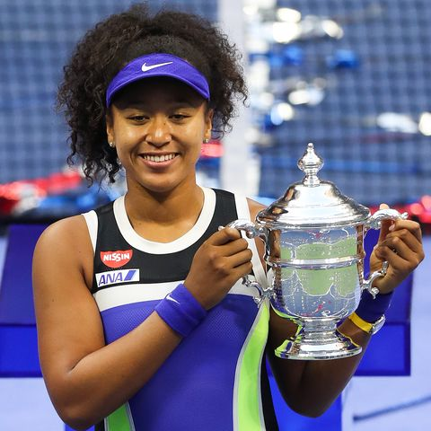
Do you know _____?
________________________________________
________________________________________
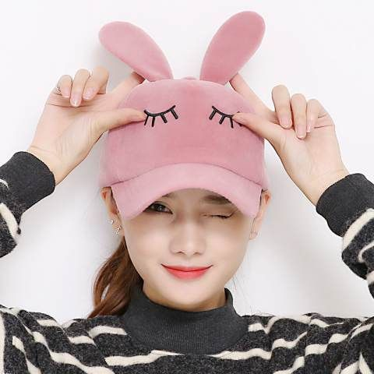
Whose cap is this?
__________________________________________
__________________________________________
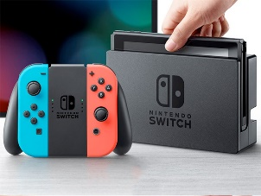
Do you know _____?
________________________________________
________________________________________
Do you know ______?
_________________________________________
_________________________________________
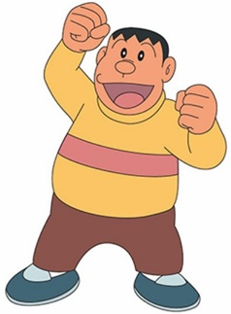
Do you know _____?
__________________________________________
__________________________________________
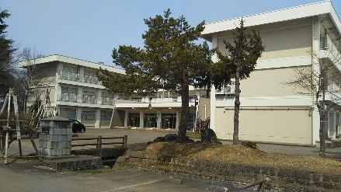
Whose school is this?
_______________________________________
_______________________________________

