Name:_____________________________________________ Class:1-________
Make a sentence using your card.
Ex. The elephant boy looks sad. 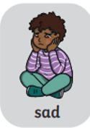 The girl’s hair looks long. 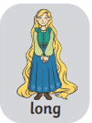
O
G
N
I
B

