Monday  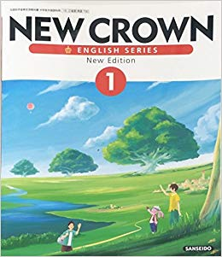  English | Tuesday  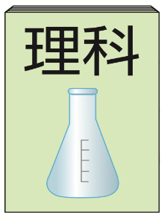  science | Wednesday  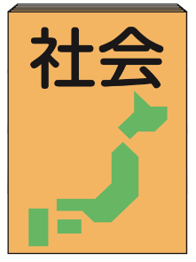  social studies
Thursday  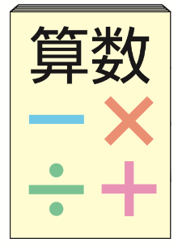  math | Friday  home economics | Saturday  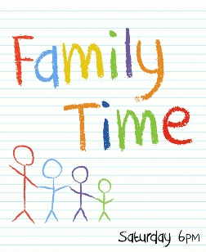  family time
Monday  Japanese | Tuesday  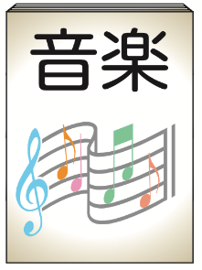  music | Wednesday  fine arts
Thursday  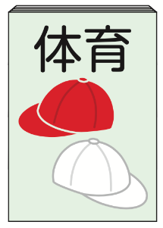  P.E. | Friday  industrial arts | Sunday  friend time

Name: ____________ Class: _____ Number: _____
English is on Fun Day!!!
Sunday | Monday | Tuesday | Wednesday
Thursday | Friday | Saturday

P.E. | math | science | music
Japanese | fine arts | home economics | English
social studies | industrial arts | family time | friends time
Sunday
Monday
Tuesday
Wednesday
Thursday
Friday
Saturday
My Week
‘English is on Wednesday’ ‘Game time is on Sunday’
- ___________________________________________________
- ___________________________________________________
- ___________________________________________________
- ___________________________________________________

