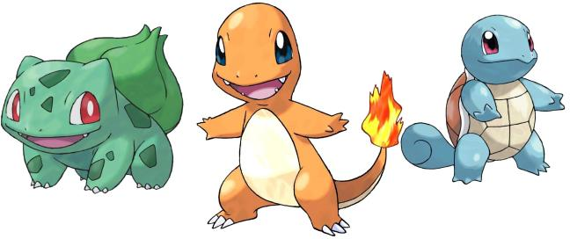
Name: __________ Class: ___ Number: ___ Date: ___/___
We saw some Pokemon.
They were cute.
- Where did Kitty go last weekend?
___________________________________________________________________
__________________________________________________ (fun)
- What did you do yesterday?
___________________________________________________________________
_____________________________________________________
- What did Doraemon see on Sunday?
_____________________________________________________
_________________________________________________ (big)
- When did you watch a movie?
______________________________________________________
______________________________________________________
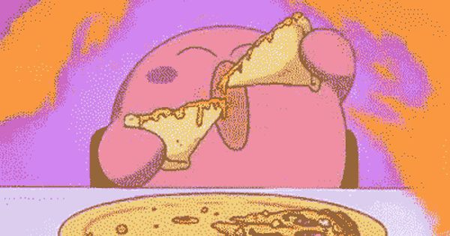
- What did Kirby eat on Sunday?
______________________________________________________
______________________________________________ (delicious)
- Where did you swim last year?
______________________________________________________
______________________________________________________
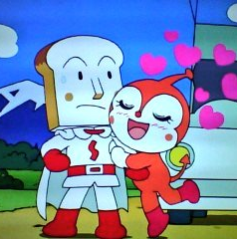
- Who did Dokinchan meet in the park?
______________________________________________________
_________________________________________________ (kind)
- What time did you come to school?
____________________________________________________
____________________________________________________
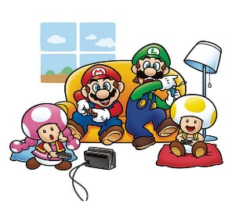
- What did Mario and his friends do at home?
____________________________________________________
___________________________________________ (The games)
- Who did you speak with yesterday?
____________________________________________________
____________________________________________________
- What did Vader drink this morning?
____________________________________________________
______________________________________________ (cold)
- When did you get a present?
____________________________________________________
____________________________________________________
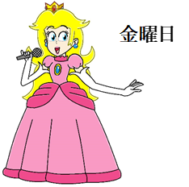
- When did Peach sing a song?
____________________________________________________
___________________________________________ (beautiful)
- Where did you do last night?
___________________________________________________
___________________________________________________
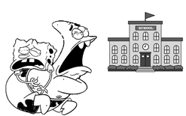
- Where did Sponge Bob and Patrick go last week?
______________________________________________________________
____________________________________________ (happy)

