① Let's write an email!

A: Use the words in the box to fill in the blanks.
phone paper attaching
forward look

- I’m sorry I missed your ______________ call.
- Let’s put some ideas on ______________.
- I’m _____________ some pictures to this email.
- I’m looking ______________ to talking with you.
- Take a _____________.
B: Draw a line to match and complete the sentences.

- Take ・ ・the email.
- How’s ・ ・tomorrow.
- See you ・ ・I didn’t write sooner.
- I’m sorry ・ ・care.
- Thanks for ・ ・everything?
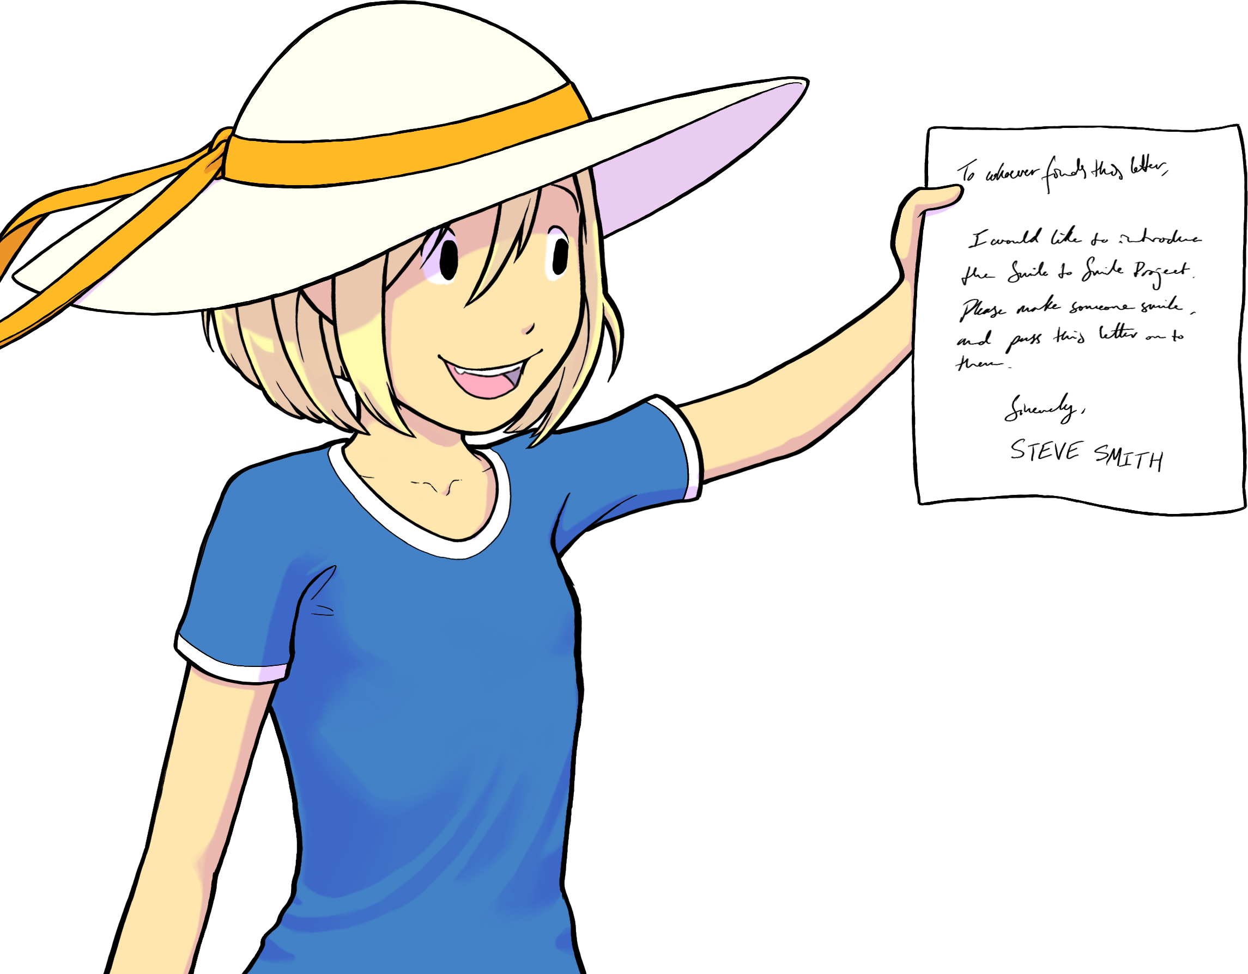
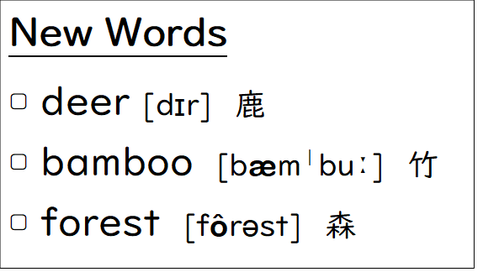

② Please write a reply email to Asami.
タイトル | About This Saturday
はじめのあいさつ | Hi, Josh.
導入 | How are you? I’m good!
内容 | Yesterday, I went to Nara Park and saw a lot of deer there. They were very friendly!  By the way, are you free this Saturday? I want to go to Kyoto with you to see the bamboo forest. I heard it’s very beautiful! If you have time, let’s go together.
まとめ | I can’t wait to meet you.
終わりのあいさつ | Take care.
署名 | Asami

タイトル  Title | About This Saturday
はじめのあいさつ
Initial greeting
Introduction
内容  Content  (Things you want to say, etc.) | ____________________________________________________________________________________________________________________________________________________________________________________________________________________________
まとめ
Summary
終わりのあいさつ  Closing greetings | Bye for now,
署名
Your name

