This mini-book was created by:

Group ______

________________________________
________________________________
________________________________
________________________________
________________________________

________________

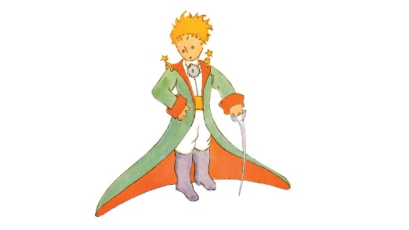

--

When the Little Prince visits earth, what questions will he ask us?

Characters
___________________________________
___________________________________
___________________________________
___________________________________

__________________________________
__________________________________
__________________________________
__________________________________

___________________________________
___________________________________
___________________________________
___________________________________

__________________________________
__________________________________
__________________________________
__________________________________
Unlocking words
Word: ________________________
Meaning: _______________________________________
_______________________________________
Sentence: _______________________________________
Word: ________________________
Meaning: _______________________________________
_______________________________________
Sentence: _______________________________________

Word: ________________________
Meaning: _______________________________________
_______________________________________
Sentence: _______________________________________

Word: ________________________
Meaning: _______________________________________
_______________________________________
Sentence: _______________________________________

Word: ________________________
Meaning: _______________________________________
_______________________________________
Sentence: _______________________________________

Summary
____________________________________________
____________________________________________
____________________________________________
____________________________________________
____________________________________________
____________________________________________
____________________________________________
____________________________________________
____________________________________________
____________________________________________
____________________________________________
____________________________________________
____________________________________________
____________________________________________
____________________________________________
____________________________________________
____________________________________________

