Name: _____________ Class: ___ Number: ___ Date: __/__
SPEAKING RACE
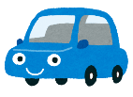  START | _____ is a food eaten in _____  That’s  Cool! | I have a ___ used to study.  Me  Too! | ___ is an anime that has cute __  Oh  Really! | I want a ___ that has a cool design  Wow!
____ is a town that has nice __

That’s
Great!
 |  | 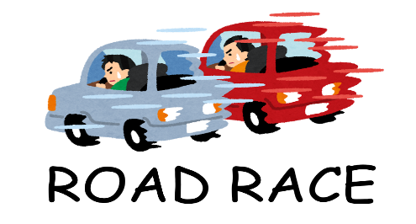 |  | __ is the singer who sings ___.  That singer  is COOL!
FINISH | ___ is a game I play at ___  That’s  Nice! | __ is a hero  many people love  Me,  Too! | ___ are animals that eat meat.  That’s  True! | ____ is a sport starting with T.  That’s  Right!
WRITING RACE ONE
- I’ve _______ here _____________________________.
- _________________
- ________________________________________ (already)
- _________________________________________________
WRITING RACE TWO
- ___________ is a food ________________________________
- ________ are people _____________________________
- ___________ is ___ TV show ____________________________________
- I have __ _______ ____________________________________________
WRITING RACE THREE
- ______________________________________________________ (yet)
- __________________________________________________________________
- __________ are _______________________________________________
- _______________________________________________________ (starting)
WRITING RACE FOUR
- _________________________________ _____ I was _______
- _______________________________________________________ (bought)
- __________________________________________________________________
- __________________________________________________________ (sells)
WRITING PRACTICE
Please tell me about your favorite thing.
___________________________________________________________________
___________________________________________________________________
___________________________________________________________________
___________________________________________________________________
Please tell me about something else you like.
___________________________________________________________________
___________________________________________________________________
___________________________________________________________________
___________________________________________________________________
RACE ONE 1. How long have you lived in Uonuma?
2. Have you ever been to Osaka?
3. What have you eaten already today?
4. How many times have you played sports this week?
RACE TWO 1. What is a food starting with M?
2. Who are people who work in schools?
3. What is a TV show that is seen on Sundays?
4. What do you have that was made in Japan?
RACE THREE 1. What haven’t you used yet today?
2. Where have you been this year?
3. What are animals that people see in the zoo?
4. What is a day starting with S?
RACE FOUR 1. What have you liked since you were 5?
2. What do you use that you bought at Aeon?
3. What are animals starting with B?
4. What is a shop which sells delicious cakes?

