Prepositions
Name:______________________________________ Class: 1-_____ No.:______ NH1 - U11
There is / There are

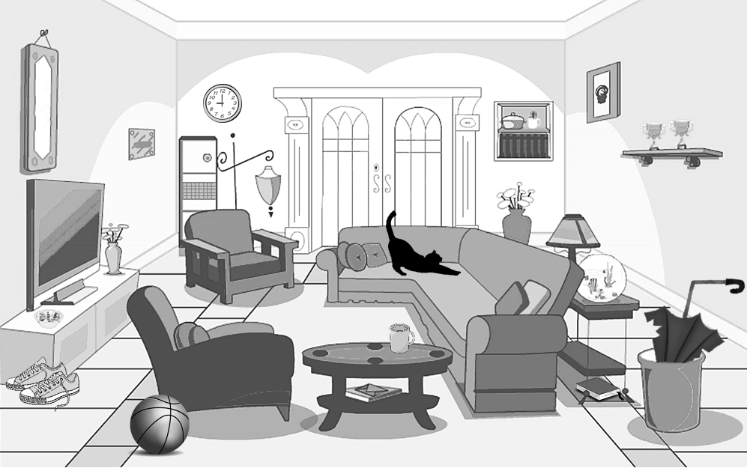

- There is a _________________________ under the table.
- There are two ______________________________ on the shelf.
- ___________________________________________________________ by the chair.
- ___________________________________________________________ on the table, behind the sofa.
- There is a cat ___________________________________________________________________________
- _________________________________________________________________________________________
- _________________________________________________________________________________________
- _________________________________________________________________________________________
- _________________________________________________________________________________________
- ________________________________________________________________________________________

