Name: ____________________
Japanese Stuff

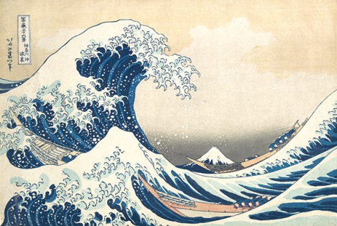
Please explain ukiyo-e.

Ukiyo-e are prints that artists made with wood blocks.
Many ukiyo-e have scenes of Mt. Fuji.

- ______________________

- ______________________

- ______________________

- ______________________

- ______________________

- ______________________

- ______________________

- ______________________

- ______________________

- ______________________

Explain about~

- Mt. Fuji富士山
- Koinoboriこいのぼり
- Doraemonドラえもん
- Tanabataたなばた
- Kyoto京都
- Hinamatsuri ひなまつり
- Sumoすもう
- Sakura桜
- Takoyakiたこやき
- Undoukai運動会

