Name:__________________________ Class:________ Number:______
Ask a favor
Hint box:
I can hold it. Give me a pen
I like salmon Here you are
Hold my bag Buy me some sushi
Which kind do you like, salmon or tuna?

Part 1: Let’s write a conversation.
Use the hint box to fill in the gaps.
ヒントボックスを使用して空欄を埋めます
- You : Excuse me. Can I ask you a favour?
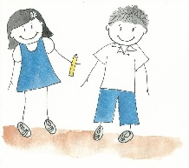
Friend: Sure.
You : Could you ___________________________________________.
Friend: OK. No problem. ______________________________________.
You : Thank you.

- You : Excuse me. Can I ask you a favour?
Friend: Sure.
You : Could you ___________________________________________.
Friend: OK. No problem. ______________________________________.
You : Thank you.

- You : Excuse me. Can I ask you a favour?
Friend: Sure.
You : Could you ____________________________________________________.
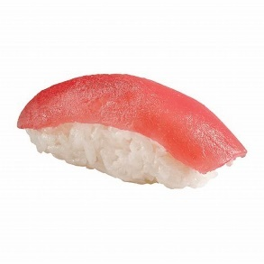
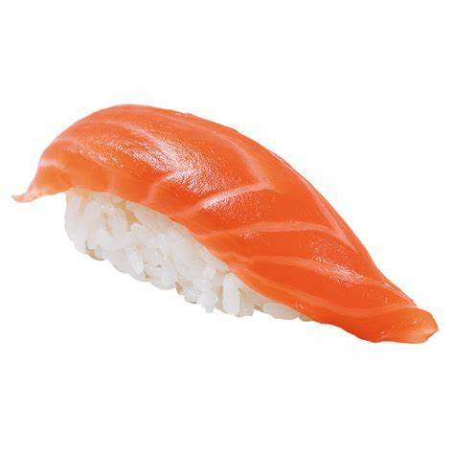
Friend: OK. No problem. _______________________________________________.
You : __________________________.
Part 2: Let’s practise talking in pairs.
Practise talking in pairs then change and read again.
ペアで話す練習をしてから、交代してもう一度読んでください。

