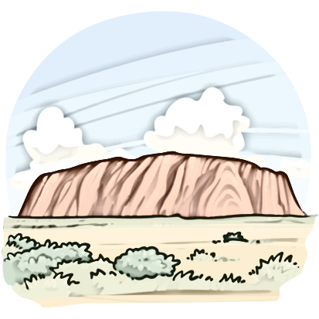
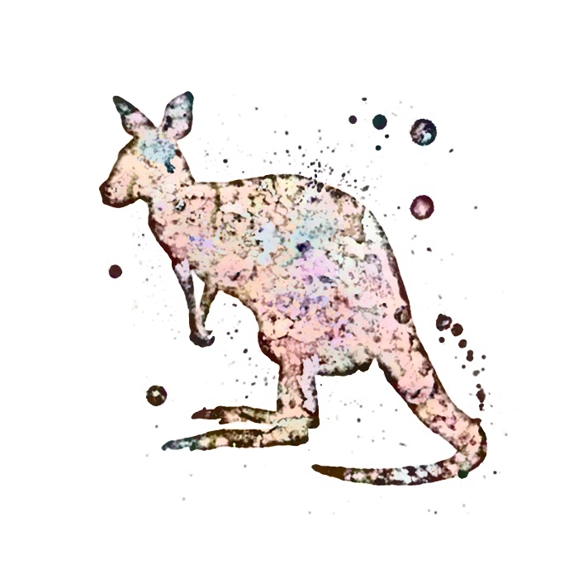
PROTECT
Name: _________________Class: _______ Number: ____
ULURU
- What is Uluru?
________________________________________________________
________________________________________________________
- How many people visit it every year?
________________________________________________________
________________________________________________________
- Why is Uluru important to the Anangu?
________________________________________________________
________________________________________________________
- Are the Anangu happy people visit Uluru?
________________________________________________________
________________________________________________________
- What bad things do some visitors do?
________________________________________________________
________________________________________________________
- What is an important place in Japan?
________________________________________________________
________________________________________________________
- What will you give a sad friend?
________________________________________________________
________________________________________________________
- When do you feel happy?
________________________________________________________
________________________________________________________
- When do you feel hungry?
________________________________________________________
________________________________________________________
- What will you give an angry friend?
________________________________________________________
________________________________________________________
- What do you have to do if your teacher looks angry?
________________________________________________________
________________________________________________________
- What do you have to do if you go to another country?
________________________________________________________
________________________________________________________
- What is there for visitors in your town?
________________________________________________________
________________________________________________________
TEAM: ________
1 | 2 | 3 | 4 | 5 | 6 | 7
8 | 9 | 10 | 11 | 12 | 13

TEAM: ________
1 | 2 | 3 | 4 | 5 | 6 | 7
8 | 9 | 10 | 11 | 12 | 13

TEAM: ________
1 | 2 | 3 | 4 | 5 | 6 | 7
8 | 9 | 10 | 11 | 12 | 13

TEAM: ________
1 | 2 | 3 | 4 | 5 | 6 | 7
8 | 9 | 10 | 11 | 12 | 13

TEAM: ________
1 | 2 | 3 | 4 | 5 | 6 | 7
8 | 9 | 10 | 11 | 12 | 13

