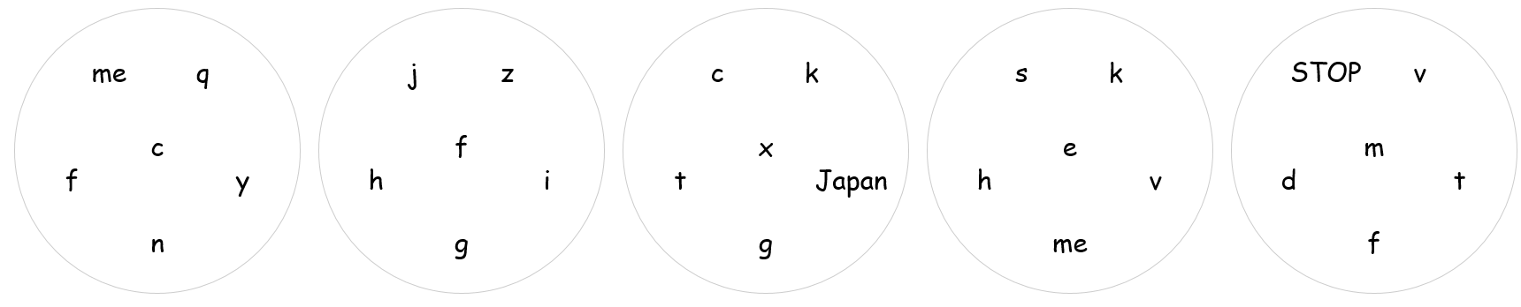
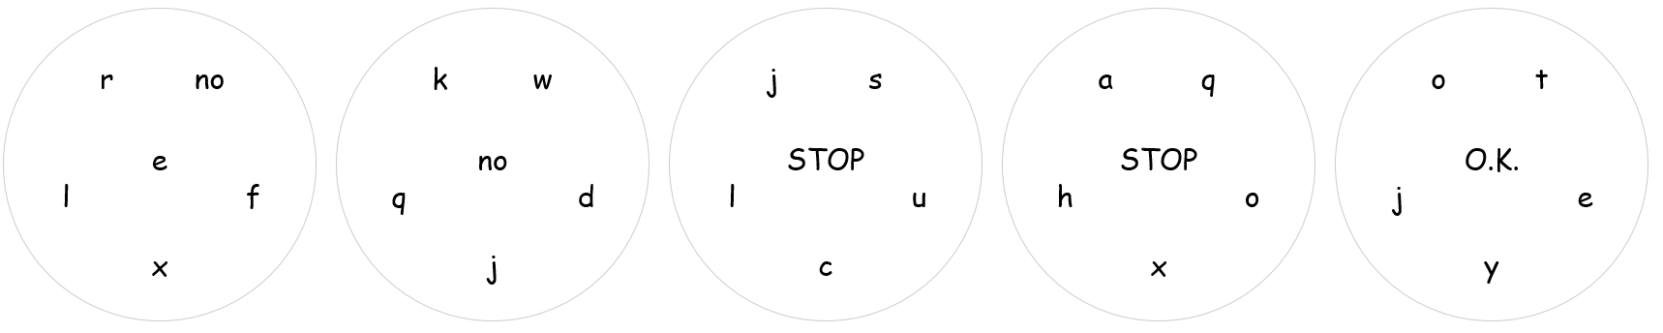
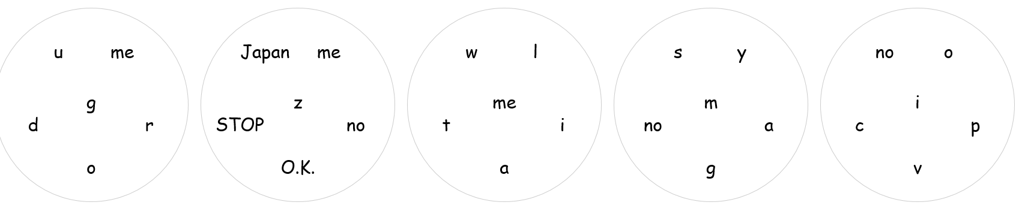
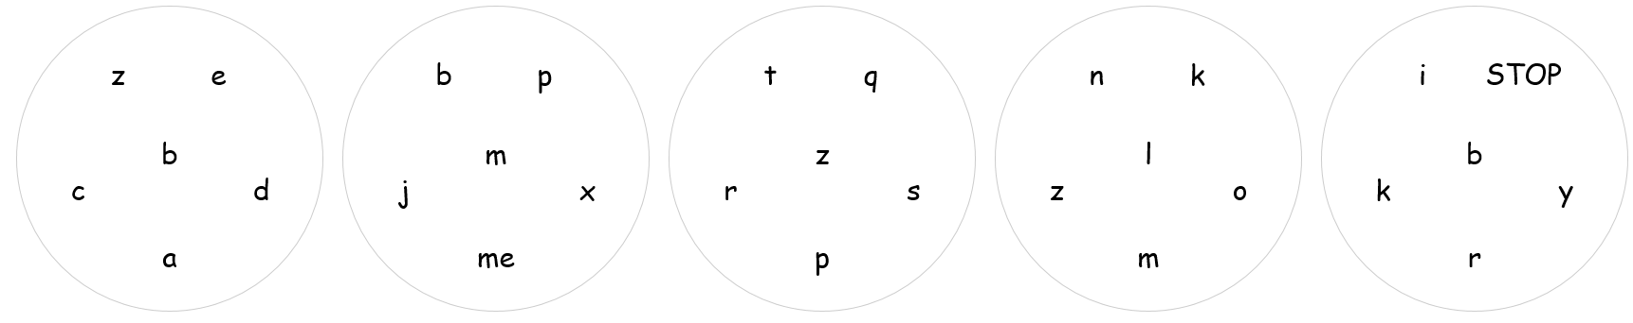
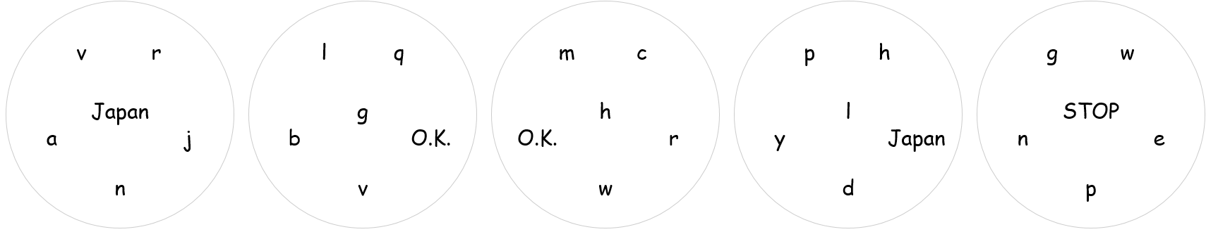
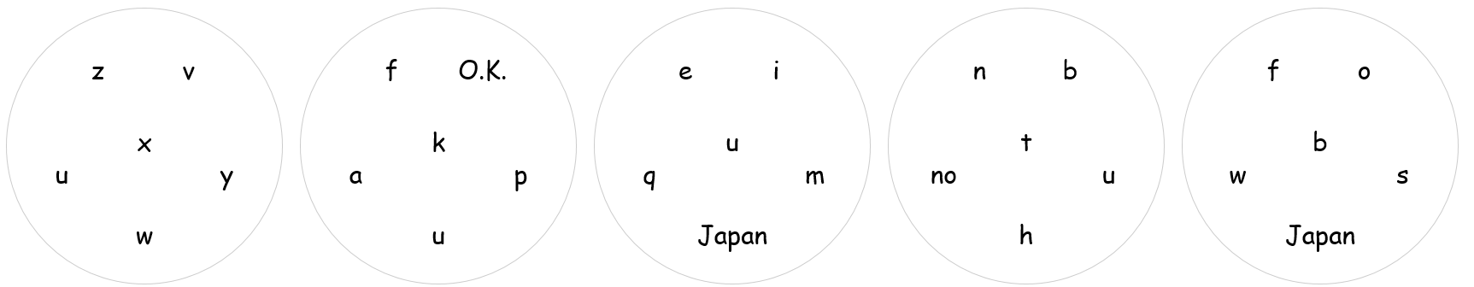
Spot it small letters

1 | a
2 | b
3 | c
4 | d
5 | e
6 | f
7 | g
8 | h
9 | i
10 | j
11 | k
12 | l
13 | m
14 | n
15 | o
16 | p
17 | q
18 | r
19 | s
20 | t
21 | u
22 | v
23 | w
24 | x
25 | y
26 | z
27 | O.K.
28 | no
29 | STOP
30 | me
31 | Japan
32

Spot it http://www.aaronbarker.net/2015/10/i-made-a-spot-it-clone/
http://www.aaronbarker.net/spot-it/spot-it.html
https://www.altopedia.net/activities/1181-make-your-own-dobble
Data should be set, 13 items or 31 or 57 (I think…)
Using the nice new PC is good, to snip and to copy something. Need to go to START game and can get a lot to snip at one go
Dobble
ALSO CALLED SPOT IT
Matching card game
[ http://www.aaronbarker.net/spot-it/spot-it.html ] .

