Did you…? BINGO
Did you _____________?
eat breakfast yesterday?  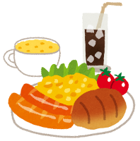  名:______________________ | go to the park yesterday?  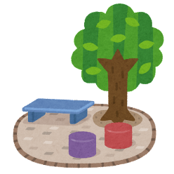  名:______________________ | watch TV yesterday?  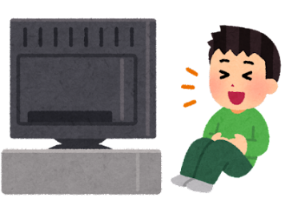  名:______________________
play games yesterday?  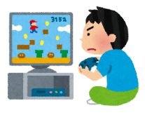  名:______________________ | sing karaoke yesterday?  名:______________________ | use a tablet yesterday?  名:______________________
read manga yesterday?  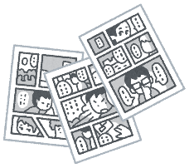  名:______________________ | drink cola yesterday?  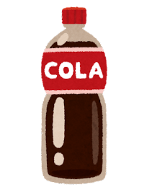  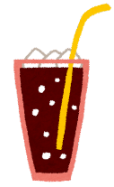  名:______________________ | take a bath yesterday?  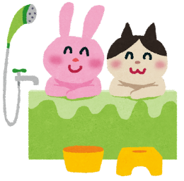  名:______________________
Yes, I did. / No, I didn’t

Let’s write about our friends!
Tom
ate school lunch
例._______________ ______________________________ yesterday.
(原形 ➜ 過去形 eat ➜ ate)
(友達の名前)
- _______________ ______________________________ yesterday.
- _______________ ______________________________ yesterday.
- _______________ ______________________________ yesterday.

