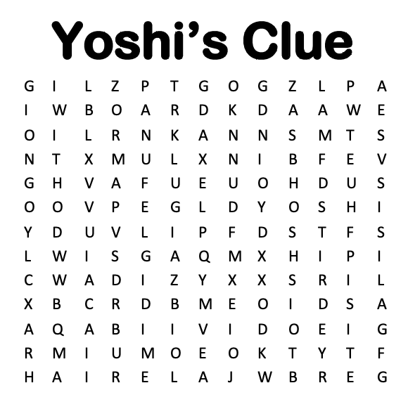

PLAYED

VIDEO / BOARD

GAMES

WITH

MARIO / LUIGI / WARIO / DIDDY

PLAYED

VIDEO / BOARD

GAMES

WITH

MARIO / LUIGI / WARIO / DIDDY

PLAYED

VIDEO / BOARD

GAMES

WITH

MARIO / LUIGI / WARIO / DIDDY

PLAYED

VIDEO / BOARD

GAMES

WITH

MARIO / LUIGI / WARIO / DIDDY

PLAYED

VIDEO / BOARD

GAMES

WITH

MARIO / LUIGI / WARIO / DIDDY

PLAYED

VIDEO / BOARD

GAMES

WITH

MARIO / LUIGI / WARIO / DIDDY

PLAYED

VIDEO / BOARD

GAMES

WITH

MARIO / LUIGI / WARIO / DIDDY

PLAYED

VIDEO / BOARD

GAMES

WITH

MARIO / LUIGI / WARIO / DIDDY