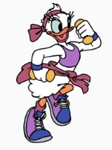
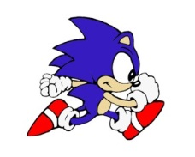
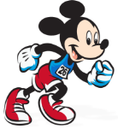
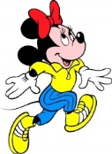
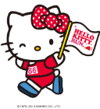
Character Races
Name: _________________Class: _______ Number: ____
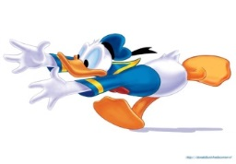

ROUND ONE
- New Crown is a book that is wrote in English. (fix it)
________________________________________________________
- that/a big/I have/has/house/friend/a
________________________________________________________
- ~ is a ~ that was ~ by Natsume Soseki.
________________________________________________________
- What is a ger?
________________________________________________________
ROUND TWO
- Toy Story was a famous movie which made by Pixar. (fix it)
________________________________________________________
- which/goes/the bus/that/to koide/is not
________________________________________________________
- ~ is ~ athlete who ~ tennis well.
________________________________________________________
- Who is George Lucas?
________________________________________________________
ROUND THREE
- Do you want to eat the pizza that my mother maked yesterday? (fix it)
________________________________________________________
- is a/that/helped make/’we are the world’/many musicians/song
________________________________________________________
- ~ is the ~ that ~ love to study.
________________________________________________________
- Where do you want to go? Why?
________________________________________________________
________________________________________________________
ROUND FOUR
- are able/in the/people’s/fireworks/summer we/love of/to see
________________________________________________________
- What sports events has Brazil hosted?
________________________________________________________
- ~ is a festival that ~ have in Uonuma. ~
________________________________________________________
________________________________________________________
- What is Carnival?
________________________________________________________
________________________________________________________

