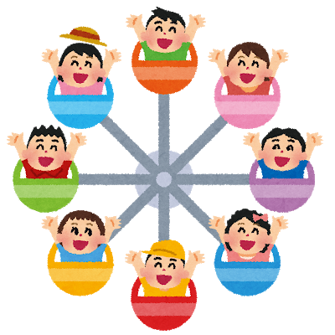
Unit 0 & 1 Vocabulary Puzzle
Down
2. 予約
3. We call the blue robot cat (___).
6. 宿題
7. I will (___) you some pictures of Tokyo Tower.
8. I’m thirsty I’m going to (___) an Aquarius at 7-11.

Across
1. Excuse me. I have a (___) with my room.
4. What are you (__) to do this weekend? I’m (___) to stay at home.
5. This is a ride. It is a circle shape. It is tall.
7. シートベルト
9. 休日
10. クッキー
11. 面白い

Answer Sheet
Across
1. Excuse me. I have a (problem) with my room.
4. What are you (going) to do this weekend? I’m (going) to stay at home.
5. This is a ride. It is a circle shape. It is tall. (Ferris Wheel)
7. シートベルト(Seatbelt)
9. 休日 (holiday)
10. クッキー (cookie)
11. 面白い (interesting)

Down
2. 予約 (reservation)
3. We call the blue robot cat (Doraemon).
6. 宿題 (homework)
7. I will (show) you some pictures of Tokyo Tower.
8. I’m thirsty I’m going to (buy) an Aquarius at 7-11.

