**Alphabet Pyramid**

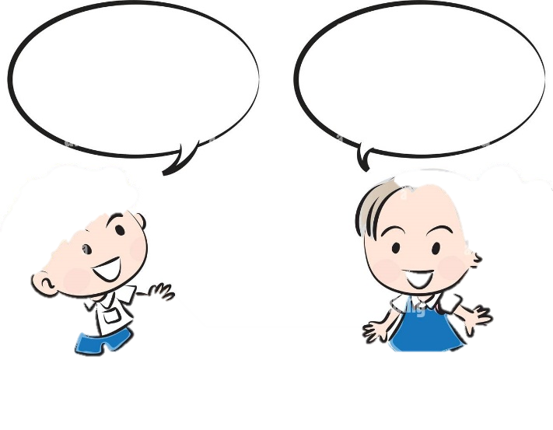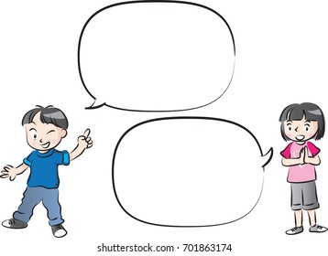

**I want to study   
science.**

a e

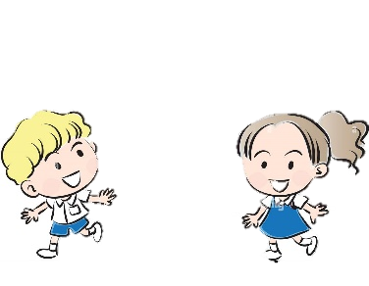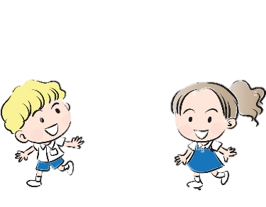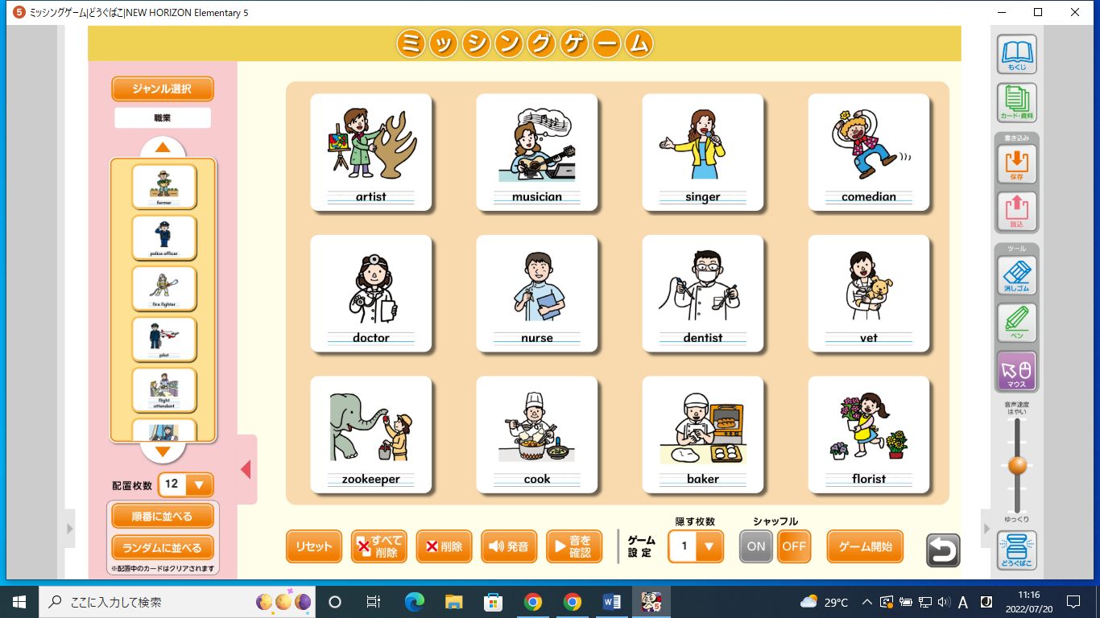****

**I want to   
be a doctor!**

**What do you   
want to be?**

**What do you   
want to study?**

g z g z g z g

p q p q p q

m n m n m

i j i j

b d b

**Alphabet Pyramid**



**I want to study   
science.**

a e



**I want to   
be a doctor!**

**What do you   
want to be?**

**What do you   
want to study?**

g z g z g z g

p q p q p q

m n m n m

i j i j

b d b