Name: __________________
Let’s Write!
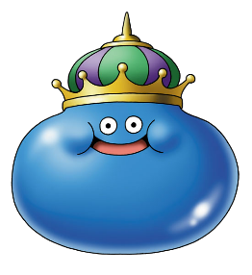
I am Slime. I like blue. I can sing.
I am from Dragon Quest.
I have eggs and blue juice for breakfast.
Do you play Dragon Quest?

- I am... □I like… □I can… □I am from…
□I have… □Do you…? Can you…?
_______________________________________________________________________________
_______________________________________________________________________________
_______________________________________________________________________________
________________________________________________________________________________
________________________________________________________________________________

